Earth Space Science: Energy Resources
Building an Energy Efficient Life
The following learning activities were backwards planned to facilitate the development of students’ knowledge and skills for mastery of this NGSS Performance Expectation. Not all of the dimensions and CCSS are covered in the following activities and teachers are encouraged to address them where possible.
 | MS-ESS3 Earth and Human Activity
Students who demonstrate understanding can:
MS-ESS3-3. | Apply scientific principles to design a method for monitoring and minimizing a human impact on the environment.* [Clarification Statement: Examples of the design process include examining human environmental impacts, assessing the kinds of solutions that are feasible, and designing and evaluating solutions that could reduce that impact. Examples of human impacts can include water usage (such as the withdrawal of water from streams and aquifers or the construction of dams and levees), land usage (such as urban development, agriculture, or the removal of wetlands), and pollution (such as of the air, water, or land).]

 | The performance expectation above was developed using the following elements from the NRC document A Framework for K-12 Science Education:
 | Constructing Explanations and Designing Solutions  Constructing explanations and designing solutions in 6–8 builds on K–5 experiences and progresses to include constructing explanations and designing solutions supported by multiple sources of evidence consistent with scientific ideas, principles, and theories.  - Apply scientific principles to design an object, tool, process or system. (MS-ESS3-3) |  | ESS3.C: Human Impacts on Earth Systems  - Human activities have significantly altered the biosphere, sometimes damaging or destroying natural habitats and causing the extinction of other species. But changes to Earth’s environments can have different impacts (negative and positive) for different living things. (MS-ESS3-3)  - Typically as human populations and per-capita consumption of natural resources increase, so do the negative impacts on Earth unless the activities and technologies involved are engineered otherwise. (MS-ESS3-3),(MS-ESS3-4) | Influence of Science, Engineering, and Technology on Society and the Natural World  - All human activity draws on natural resources and has both short and long-term consequences, positive as well as negative, for the health of people and the natural environment. (MS-ESS3-1),(MS-ESS3-4)  - The uses of technologies and any limitations on their use are driven by individual or societal needs, desires, and values; by the findings of scientific research; and by differences in such factors as climate, natural resources, and economic conditions. Thus technology use varies from region to region and over time. (MS-ESS3-2),(MS-ESS3-3)
Connections to other DCIs in this grade-band:
MS.LS2.A MS.LS2.C MS.LS4.D
Articulation of DCIs across grade-bands:
3.LS2.C 3.LS4.D 5.ESS3.C HS.LS2.C HS.LS4.C HS.LS4.D HS.ESS2.C HS.ESS2.D HS.ESS2.E HS.ESS3.C HS.ESS3.D
Common Core State Standards Connections:
 |  |  | WHST.6-8.7 | Conduct short research projects to answer a question (including a self-generated question), drawing on several sources and generating additional related, focused questions that allow for multiple avenues of exploration.
 | WHST.6-8.8 |  |  |  | Gather relevant information from multiple print and digital sources, using search terms effectively; assess the credibility and accuracy of each source; and quote or paraphrase the data and conclusions of others while avoiding plagiarism and following a standard format for citation.
6.RP.A.1 |  |  |  |  | Understand the concept of a ratio and use ratio language to describe a ratio relationship between two quantities.
 |  | 7.RP.A.2 |  |  | Recognize and represent proportional relationships between quantities.
 |  | 6.EE.B.6 |  |  | Use variables to represent numbers and write expressions when solving a real-world or mathematical problem; understand that a variable can represent an unknown number, or, depending on the purpose at hand, any number in a specified set.

7.EE.B.4 |  | Use variables to represent quantities in a real-world or mathematical problem, and construct simple equations and inequalities to solve problems by reasoning about the quantities.

 | Steam Turbine | Renew a Chip | Extracting Fossil Fuels and Uses
Student Experience | Students will:  - Generate questions about electricity  - Observe the effects of heat energy on water  - Model the action of a turbine  - Revise their model design of a turbine  - Compare a model to a representation of a real turbine  - Make connections between the various forms of energy | Students will:  - Conduct a simulation of energy use  - Collect and analyze data  - Organize data in a variety of ways  - Communicate what they have learned about energy resources | Students will:  - Model an oil reserve  - Read an article about finding oil and drilling  - Compare the model to real life  - Use the model to predict effects on the environment  - Write a journal entry
T4T Material | Various materials from the cart | Black and Red Chips  Black specimen cups | .Shoe boxes, cat litter
Big Idea | Energy can come in many forms. Electricity is a widely used source of energy. Electricity is produced from fossil fuels that power turbines. Energy can be changed from one form to another, but in the process, some of the energy is converted into heat. | Students know that energy resources are both renewable and nonrenewable and that humans use both kinds of energy. Students know the benefit to using renewable resources as opposed to non-renewable. Students analyze data to investigate energy use over time. | Fossil fuels are found in key places around the world. A reserve is the amount of resource obtainable with current technologies. Reserves of fossil fuels are found below the earth. Extraction of fossil fuels can be harmful to the environment. Petroleum is a raw material for a wide variety of products.
Connection to Culminating Activity | Electricity is produced using fossil fuels | There are 2 types of energy and as a society we are moving towards using more renewable resources. | How using fossil fuels is impacting our environment.
CA Standards | 6a. Students know the utility of energy sources is determined by factors that are involved in converting these sources to useful forms and the consequences of the conversation process.  3b. Students know that when fuel is consumed, most of the energy released becomes heat energy. | 6a. Students know the utility of energy sources is determined by factors that are involved in converting these sources to useful forms and the consequences of the conversation process.  6b. Students know different natural energy and material resources, including air, soil, rocks, minerals, petroleum, fresh water, wildlife and forests and know how to classify them as renewable or nonrenewable. | 6a. Students know the utility of energy sources is determined by factors that are involved in converting these sources to useful forms and the consequences of the conversation process.  6b. Students know different natural energy and material resources, including air, soil, rocks, minerals, petroleum, fresh water, wildlife and forests and know how to classify them as renewable or nonrenewable.  6c. Students know the natural origin of the materials used to make common objects.
Next Generation Science Standards | - | MS-ESS3-4 | MS-ESS3-4
Time | About three 40 minute time periods | About four 40 minute time periods | Two 40 minute time periods

 | Energy is Blowin’ in the Wind | Renewable Energy: Wind
Student Experience | Students will:  - Be introduced to the project  - Be introduced to the materials available to build their particulate matter sampler.  - Design and construct particulate matter sampler.  - Use particulate matter sampler to collect data.  - Analyze data and record data using Google pages  - Share data and reflect on design  EXTRA: Write a letter to the principal to suggest ways that students can reduce the amount of pollution on campus. | Students will:  - Read about wind energy  - Be introduced to the project  - Be introduced to the materials available to design windmill  - Develop a plan for their windmill  - Execute their plan  - Test and redesign  - Evaluate and communicate results
T4T Material | Vaseline, various cart materials | Various cart materials
Big Idea | Air pollution is one of the effects nonrenewable resources has on the environment. Air quality is rated based on the amount of particulate matter. Scientists use particulate matter samplers to collect particulate matter. | There are alternate sources of energy to fossil fuels such as wind, solar energy, water power, nuclear fission and geothermal energy. Wind energy can be generated on both a large and small scale. The design and materials used can enhance the efficiency of windmills.
Connection to Culminating Activity | How does pollution affect their own environment and ways to reduce pollution. | Alternatives to using fossil fuels
CA Standards | - | 6b. Students know different natural energy and material resources, including air, soil, rocks, minerals, petroleum, fresh water, wildlife and forests and know how to classify them as renewable or nonrenewable.
Next Generation Science Standards | MS-ESS3-3 | MS-ESS3-3
Time | Two to three 40 minute time periods | Two to three 40 minute time periods

 | Culminating Activity – Building an Energy Efficient Life
 | Retaining Heat Energy | Energy House | Creating a brochure and sell house
Student Experience | Make predictions as to which material is the best insulator  Identify the best source of insulation | Build an energy house  Calculate the cost of building  Calculate the money saved | Create a sales pitch  Create a brochure
T4T Material | Plastic wrap | Various cart materials, plastic bags, glue guns | -
Big Idea | Material affects insulation. | Residential buildings require energy for heating, cooling and lighting (among other uses). Buildings can lose heated or cooled air to the outside through openings. Building design and materials can be used to minimize loss of heated or cooled air. | People can make choices in the products that they buy and their daily lives to minimize human impact on the environment
CA Standards | 3b. Students know that when fuel is consumed, most of the energy released becomes heat energy. | - | -
Next Generation Science Standards | MS-ESS3-3 | MS-ESS3-3 | -
Time | One 40 minute time period | Two 40 minute time periods | 2-3 40 minute time periods

Total Time:
(19) 40 minute class periods
*Teacher can adjust pacing for any lesson and lab write up based on student needs

Readings for the Unit:
http://www.need.org/files/curriculum/guides/Intermediate%20Energy%20Infobook.pdf

Lesson Plans for Steam Turbine
Essential Question: Where does electricity come from?

Objective:

SWBAT describe how electricity gets to their house/school and one way electricity is produced.

Engage & Explore:

- Have you ever experienced a power outage or a black out? What happened? How did you feel? How long did it last? What caused the black out?
- Look around the classroom, what items rely on energy resources to work?
  - Students generate a list
- What happens elsewhere during a blackout? (What happens at the shopping mall? What happens to traffic? What happens at hospitals?)
- Show students two pictures. Compare the two photographs. They are satellite images of the biggest blackout in U.S. history. It occurred on August 14, 2003, leaving 50 million people without power. The first is 20 hours before the black out and the second is 7 hours after the initial blackout started.
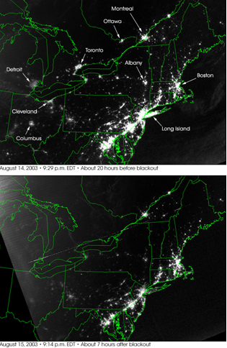
http://visibleearth.nasa.gov/view_rec.php?id=18796
- How does electricity get to your house or school? What is the point of origin for the transmission of the power? How is it transmitted? (Addition questions: How is electricity supplied to so many homes and businesses? Where does electricity come from? Do you have electricity transmission lines near your house?)
- How is electricity generated from your area? Is electricity generated the same way all across the country? What are some other ways to generate electricity?
- Teacher gives background
  - Explain that electricity is generated when a coil turns inside a magnet. This rotation is the basis for generating power on a large scale.
  - Explain that millions of homes and businesses are powered by electricity. We need big power plants to generate enough electricity to meet those needs.
  - To generate electricity, a turbine needs a generator. There are various ways that this can be achieved. Today we are going to look at one way.
- Explain that they are going to build a turbine. They will demonstrate the principle for using mechanical energy to turn generators.
a. Students collect data and answer questions for analysis

Explain & Elaborate
- Teacher facilitates a class discussion on the model designs that worked well.
  - How was your model similar to and different from, an actual turbine generator?
  - What source of energy could produce enough steam to power your turbine?
    - Students are led in a Q&A discussion on comparing their turbine to a power plant.
    - Students will understand that turbine wheels in a real electricity generating station are fully enclosed so that the steam is under pressure, it has no where else to go and forces the blade to turn.
  - Show students the diagram of the power plant. Have students study the plant and figure out how all the parts link together to produce electricity.
    - What natural resources do you think are required for the plant to work?
    - What forms of energy do you think are produced by the plant?
    - Which form of energy do you think represents the plant’s useful output?
    - Which non-useable forms of energy do you think also leave the power plant and where do they go?
    - What do you think are the advantages of generating electricity with fossil fuels?
    - What disadvantages do you think are associated with this kind of process for producing electricity?
Evaluate
- Students discuss and write answers to the following questions:
  - How much did your turbine performance improve between the first and second design?
  - In what ways might turbine design be important for efficient generation of electricity?
  - What might go wrong in the steps to get electricity from the power station to your house?
  - What steps can you take at home to increase efficiency of energy use?
  - What are three environmental impacts of using fossil fuels for electricity generation?
Additional Resources
http://www.eia.doe.gov/energy_in_brief/slideshows/renewable_energy.html
http://www.eere.energy.gov/kids/renergy.html
http://www.energy.gov/forstudentsandkids.htm
http://www.eia.gov/energyexplained/index.cfm
http://www.energystar.gov/index.cfm?c=kids.kids_index

2. Renew-A-Chip
Essential Question: How has the use of energy resources changed over time?
Objective:

SWBAT explain the benefits of using renewable resources as opposed to non-renewable resources.

Engage and Explore
- If you fill the soda machine at the beginning of the school year, how long would the sodas last?
- Create a list of renewable and non-renewable resources as they relate to a pencil.
  - Renewable – wood and metal
  - Non-Renewable – plastic, paint, glue, graphite
- Students will conduct a simulation of resource usage. How long the supply lasts depends on the ratio of renewable and non-renewable resources. (The chips will be drawn randomly as opposed to in our lives we hope to make deliberate decisions.)
  - Demonstrate for the class two rounds of taking chips out of the bag, documenting results and replacing renewable chips. Without looking draw out of the bag ten chips and separate the RED (non-renewable) and BLACK (renewable). Record the number of red and black chips using the worksheet. Set the RED chips aside and replace the BLACK chips back into the bag. Repeat for 10 rounds or until all energy chips are gone.
  - Students work in pairs to complete the activity 2 times. (First time students only pick out 10 chips to represent energy use. Second time consider the growing use of power and energy over time; increase the amount of energy used by picking out 5 additional “energy chips” each year. (Pick 10 chips in year 1, 15 chips in year 2, 20 chips in year 3, ect.)
- Students interpret their data and draw conclusions
a. What does this activity demonstrate about our consumption of resources- what will happen if we keep using non-renewable resources?
Explain & Elaborate
- What is reality?
  - Teacher uses 5 soda bottles to give a visual representation of the fuels used to generate electricity in the US. (Fossil Fuels: 70% 1400 mL, Nuclear 20% 400 mL, Hydro 7% 140 mL, Renewables 2.5% 50 mL, Other 0.5% 10 mL)
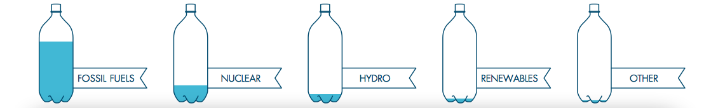
  - Teacher leads discussion to answer questions
    - What do you think will happen as the biggest bottle of fuel begins to run out? What will fill its place?
    - Will the biggest bottle ever run out? If so when? 50 years, 100 years, 200 years in the future?
  - Teacher provides students with a data table the shows the Annual Energy Used in the US 1950-2012 by Source (Quadrillion Btu)
    - Teacher reviews data with students (be sure to explain that the units here are not percentages, but units of energy)
    - Teacher has students graph data (this should be a line graph x= year y= Quadrillion Btu, students will graph each source of energy in a different color)

Evaluate

- Students analyze graphs to determine how energy resources have changed over time.
  - In 2012, how much energy was provided by fossil fuels?
  - In 2012, how much energy was provided by nuclear power?
  - In 2012, how much energy was produced by renewable resources?
- Look at the long-term trend on your graph.
  - How has the use of biomass in the United States changed since 1950?
  - How has the use of coal in the United States changed since 1950?
  - Is there any correlation between changes in coal use and changes in any other fuel use? Explain.
  - Why do you think these changes have occurred?
Additional Resources

http://www.eia.gov/totalenergy/data/annual/index.cfm
http://stem-works.com/external/activity/181
http://www.eia.gov/todayinenergy/detail.cfm?id=11951

3. Extracting Fossil Fuels and Uses

Essential Question: How is petroleum found?

Objective:

SWBAT model the process of finding petroleum and predict the effects of drilling on the environment.

Engage/Explore
Give students prompt:
“Products derived from oil, such as motor gasoline, jet fuel, diesel fuel and heating oil, supply nearly 40 percent of the energy consumed by households, businesses, and manufactures worldwide. Oil and natural gas are forms of petroleum, a word that literally means “oily rock.” Petroleum is called a fossil fuel because it is geologically very old and is found in the ground, like fossils. Abundant oil and natural gas form only where conditions in the Earth are just right.” (taken from www.energy4me.org)

How do you think geoscientists identify and explore petroleum-rich reserves? (students give various answers)

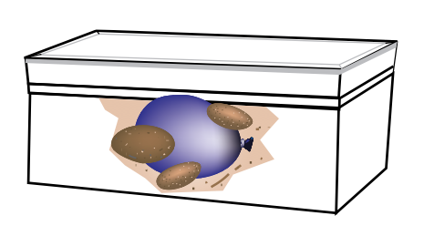
Tell students that today they have been hired as a geoscientist by Shell to locate and explore a petroleum-rich reserve.

Each team will be provided with one shoe box, cat litter, a water balloon filled with oil or water that is colored, and a few rocks. Tell students that before they begin drilling they will be creating a model for another group. (Do not have them put their names on the boxes yet)

Tell students to place an uneven layer of cat litter on the bottom of the box. Then place the small, filled balloon into the box, thinking carefully where they place it. Putting it in the middle might be too obvious or putting it against the side of the box might be too confusing. Place the rocks around/on top of the balloon and fill the rest of the box with cat litter. The box should be completely filled.

Then place the lid on the box and secure it with tape.

The teacher should then collect the boxes and redistribute making sure that each group gets a new box.

Have the students attach a sheet of graph paper to the lid of their new box. Then have the students gently tap on the box lid to listen for different sounds.

Ask students to record the areas, which they think might be worth investigating.

Before you give the students their skewers, tell them that they will be carefully probing for oil. Tell them that every centimeter they drill costs $200,000. Each time they start a new test site it costs an additional $100,000.

Students are to record their drilling strategy before beginning drilling. Once they have recorded their drilling strategy, they must propose it to you “the foreman” in order to begin drilling.

Give each group a bamboo skewer and help them mark off divisions of one centimeter starting from the tip. Remind them to record their drilling costs as they go. Students may change their strategy as they are drilling but the foreman must approve the change.

Have students keep drilling until they find oil.

Explain and Elaborate
Teacher poses question “How does this model relate to the way geoscientists actually look for and find oil?”
Teacher give students reading titled “Exploration” http://www.need.org/Files/curriculum/guides/FossilFuelsToProducts.pdf

Teacher helps students make connections to the environment.
“How might drilling have an impact on the environment?” “How do you think finding coal and removing is would be similar to oil exploration and extraction? How would it be different? “ “How would searching for natural gas and bringing it to the surface be similar to, and different from, oil discovery and extraction?”

Evaluate

Students write a short diary entry from the point of view of an engineer who has just discovered an oil reserve. Have them use evidence from the lab and the reading to explain the process through which they must go in order to retrieve the oil.

4. Energy in Blowin’ in the Wind
Essential question: How is energy affecting our environment?
Objective:

SWBAT design and build an outdoor air pollution detector and communicate the design process and results.

Engage and Explore:
Teacher begins with a demo. Teacher lights a candle, lets it burn for a few seconds and places a clear jar over the flame so that the glass touches the flame. Soot will immediately develop on the glass. Ask students “What is the black that has collected inside the jar? Does the black stuff exist when the jar is not there?”
- Ask students to share some sources of air pollution. How might scientist measure pollution? How does pollution impact society?
- Introduce activity to students
  - Read handout “Pollution Patrol” http://www.tryengineering.org/sites/default/files/lessons/pollutionpatrol.pdf
  - Explain that each team must design a particulate air pollution detection device. It must have a flat collection area, which is at least 5 cm x 5 cm. The device should have relative protection from the elements and should be able to be secured.
  - Show students the materials that they have to choose from
- Students meet and develop a plan for their device.
  - They must agree on the materials that they will need
  - They must write and draw their plan before building and have it approve by the teacher.
- Students build their collection device
  - Students may need to rethink their plans, request alternate materials, trade with other teams or start over
- Each team should place their detector at a different location around the school (near buses, parking lot, playing field ect.)
- After 72 hours, students can examine particulate matter collected by their devices using hand lenses (or microscopes)
  - Record and describe all the different types of particles they see (dust, pollen, dirt, ect.)
Explain & Elaborate
- Analyze data
  - Students should create a grid of 1 cm squares over their device’s collection area with string, securing it with tape. They should then count the number of particles in 5 random squares and take an average.
  - Students can then compare and graph findings for the different locations tested by the class
  - Students can upload data onto Google pages.
- Present finding to class
- Students develop a scale to rate air quality/air pollution at the different locations tested around the school
- Students compare their data to other schools
Evaluate
- What do you think can be done to reduce particulate pollution around your school? Students write a letter to the principal to let him/her know what can be done to reduce air pollution in and around the school.

5. Renewable Energy: Wind Energy
Essential Question: What other energy sources are there?
Objective:

SWBAT design and build a working windmill and evaluate its effectiveness.

Engage and Explore:
      - Ask your students to imagine a world when we have run out of non-renewable fuel sources (oil, gas, coal). Could your dream house survive in a world without fossil fuels? How?
      - Have you ever seen a windmill? What did it look like? What do you think it was used for? How do you think windmills work?
      - Provide students with reading “Working with Wind Energy.” Have students mark the text
      - Introduce activity to students
        - Explain that each team will design a windmill out of everyday items. The windmill will need to be able to withstand wind from a fan for at least one minute while winding a string or wire to lift a light object. You will be working on a budget and will have to “purchase” materials from your teacher to create the design. The least expensive design that meets the challenge will be considered the most efficient design.
        - Let students see the materials they have to choose from and the price of the materials.
      - Students meet and develop a plan for their device.
        - They must agree on the materials that they will need
        - They must write and draw their plan before building and have it approved by the teacher
      - Students build their windmill device
        - During construction students may decide that they need additional materials or that the design needs to be changed. Make sure students document changes and why they made them.
      - Testing phase
        - Each team will test their windmill using a fan or hairdryer (make sure to test each windmill with the same wind speed and distance)
      - Teams share out results

Explain & Elaborate
- Students analyze and evaluate their results (answer conclusion questions)
- What drawbacks does a wind turbine have as a reliable source of energy?
- What advantages does the windmill have as a renewable source of energy?
- Why are large wind turbines often located on hills?
Read about how Jay Leno is building a wind turbine to make is garage more energy efficient http://www.popularmechanics.com/cars/jay-leno/green-garage/4216780

Evaluate
- A homeowner wants to use a wind turbine to supply electricity for their home but there are no hills near the house. How should the engineer design the wind turbine so that it is most effective and where could an engineer place the wind turbine? Provide evidence for your answer.
Additional Resources
http://learn.kidwind.org

6. Using Energy Resources Wisely: Building an Energy House

Engage
- Retaining Heat Energy (teacher demo)
  - Obtain a beaker, metal can and Styrofoam cup (should all be about the same size)
  - Students predict which item will hold heat the best as well as a reason.
  - Fill the containers with the same volume of hot water
  - Place a thermometer in each cup and secure plastic wrap over the top of each container.
    - Measure and record the temperature of the water in each container.
    - Measure the temperature in each container every minute over 15 min. period.
  - Explain how your results compared to your prediction.
- Repeat the demo this time wrap 6 sheets of paper as tightly as you can around the can and the Styrofoam cup. Fold the paper in the same way each time.
  - Have students record their predictions again, noting how they think the results will compare to their previous results. Make sure they provide a reason for their prediction.
  - Repeat the procedure as before
- Use data to graph results
  - Does this evidence support your prediction and the reason you gave for it?
  - What does this tell you about retaining heat energy?
  - How can this be applied to buildings?
Explore and Explain
- Teacher introduces students to the project
  - A couple has hired you as an architect to build a house on their new plot of land they have recently purchased. After watching many recent news reports they have realized that they need to be energy conscious. In order to be energy conscious, they want a house that will save them money but not cost so much that they cannot afford it. They also would like to add a source of renewable energy to help power their house, but are not sure the best type of renewable energy to use. Lastly they need they want to hire a consultant to help them make changes to their daily lives in order to become energy conscious.

The plot of land is located in Southern California. Therefore the couple needs a house that will remain cool in the summer and retain heat in the winter. The land is about 10 acres in size. About 5 acres are covered in trees. In one corner of the plot is a very tall hill and the rest of the land is open space.

Your job is to submit a proposal to the client (teacher) before building. The client must approve the design before you begin building a model of their new home. The new home must follow local building code and save the client money. After building and testing the model you must provide the client with a report of the economic return value of their new home and the best renewable energy source to place on their property.

Lastly the client has hired part of your group as a consultant. They know that in order to be more energy conscious they must also change their lifestyle, but they are unsure of what to do. You must explain to the couple at least 4 ways that they can modify their daily habits to become more energy conscious.

Building code:
- The door must open and close. It must measure at least 10 cm x 20 cm.
- Windows do not have to open but you must be able to see through them. There must be at least 2 windows measuring at least 10 cm x 10 cm.
- The ceiling must be at least 5 cm above the top of the door.
- Insulation on the floor and walls cannot exceed 1 cm in thickness.
- No insulation can be exposed. All insulation must be covered by a ceiling, wall or floor.

  - Students are shown the materials that they have to build with, the cost of materials and a budget to work with.
- Students meet and plan their designs and the materials that will be needed to complete their design.
- Students work in groups to build their house.
- When groups are finished distribute plastic bags filled with ice cubes to each group and have the students close their houses with the bags of ice on the floor of the house. (Simulating AC)
- Measure the temperature of the classroom and record it
- After ten minutes, have each group measure the temperature inside their houses by carefully sliding a thermometer above the door and recording the measurement.
- Students calculate their energy savings on their cost sheet
- Students analyze data. How efficient was their home at maintaining its temperature? How did your cost for materials compare to the money saved in the long term? (Be sure to have students complete the cost analysis sheet)

Elaborate & Evaluate
- Now that the house is built, students must use their data to create a proposal for the couple. This proposal can be formatted in any way they decide. The class will become the client while the architects and consultants present.
- Students need to convince the couple that they are the best company to go with.
- Students must provide the couple with the cost of building the house vs. the economic return value.
- Students must provide the couple with the best renewable energy resource that should be placed on their land and why. (Students must use evidence from the unit to prove why their source is the best)
- Students will create a brochure to give to the couple that explains how they should change their daily lives to become more energy efficient.

*During all activities teacher serves as a facilitator of student learning (i.e. student centered instruction). Most tasks should be completed by students after simple directions, or facilitated questions to enhance student learning.

Accommodations
All individual accommodations for students should be met with respect to your particular students and classroom dynamics and will vary from class to class and group to group. Facilitator should always differentiate instruction by providing the necessary blend of guidance and exploration for each student group and their specific needs.

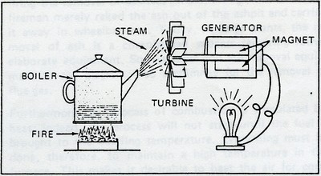
Build a Turbine

Objective: Design a turbine that will turn the fastest using the least amount of energy.

Power stations use turbines to convert kinetic energy into mechanical energy. In this lab you will build a model turbine. Then you will change the design to see if you can improve the performance of the turbine.

Directions: With the people in your engineering team, draw a diagram for your steam turbine. Be sure to include all the materials that are being used to build your turbine.
______________________ teacher approval

Once the teacher signs off your design, you may begin building. When building the fins make sure that you color one fin. Be sure to answer the questions below!

- How do you think the turbine moves?
____________________________________________________________________________________________________________________________________________________________________________________________________________________________________________________________
Once you are confident is your turbines ability to move, go to the testing station. Each group’s turbine model can be tested in turn. Put on safety goggles. Hold your turbine in the path of the steam from the glass tube.
Use the timer to count how many times the colored fin makes a complete turn in one minute. (This is the revolutions per minute or RPM). Record your data.

______________ RPM

1. What happened during your initial test? (describe what you saw)
____________________________________________________________________________________________________________________________________________________________________________________________________________________________________________________________________.
- What can you do to your turbine to make it more efficient? (spin faster)
____________________________________________________________________________________________________________________________________________________________________________________________________________________________________________________________________.
Make changes to your turbine and test again. Use the timer to count how many times the colored fin makes a complete turn in one minute. Record your data.

______________ RPM

- What happened during your final test?
____________________________________________________________________________________________________________________________________________________________________________________________________________________________________________________________________.
- What could you do to make your turbine more efficient?
____________________________________________________________________________________________________________________________________________________________________________________________________________________________________________________________________.

Conclusion:
1. Was your second design an improvement on the first?
Claim | Evidence
My second design was ____________________  on my first design. | I know this because

2. In what ways could you improve further on your design?
Claim | Evidence
I could improve further on my design by | I know this because

3. How could you generate electricity with your turbine?

Diagram showing the typical parts of an electricity power plant using fossil fuels.
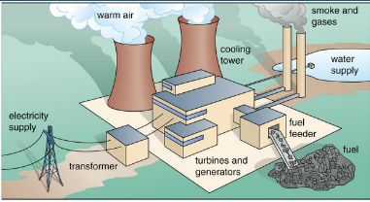

Diagram that explains the transformation of energy.
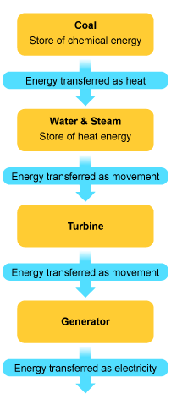

Renew-A-Chip

Procedure
Part 1

- Assign the roles of “recorder” and “excavator.”

__________________________ recorder

_________________________ excavator

- The recorder will fill out the worksheet and the excavator will pull chips out of the bag, without looking.
- Draw 10 chips out at a time, record your results and replace the “renewable” chips until you have completed round 10. Calculate the totals.

Year | Total chips removed | Number of nonrenewable chips | Number of renewable chips | Percent of chips that are renewable  Black chips x 100 %  Total chips | Number of chips remaining
1

2

3

4

5

6

7

8

9

10

Part 2: Increasing use in the number of beans used each year.
- Switch roles.
__________________________ recorder

_________________________ excavator

- Consider the growing use of power and energy over time. Repeat step 3, but this time increase the amount of energy used by picking out 5 additional “energy beans” each year (pick 10 chips in year
1, 15 chips in year 2, 20 chips in round 3, ect.)

- Record data and calculate totals.

Year | Total chips removed | Number of nonrenewable chips | Number of renewable chips | Percent of chips that are renewable  Black chips x 100 %  Total chips | Number of chips remaining
1

2

3

4

5

6

7

8

9

10

Conclusion: Answer questions in complete sentences.
- How many years did it take for the non-renewable energy sources to run out when you used 10 energy chips per year?

- How many years did it take for the non-renewable energy sources to run out when you increased the rate at which we consumed resources each year?

- What are some examples of renewable and non-renewable energy sources?

- What does this activity demonstrate about our consumption of resources- what will happen if we keep using non-renewable resources?

- Describe what happened to the proportion of renewable vs. non-renewable energy sources that remain available, as energy is use over time.

United States Annual Energy Consumption 1950 – 2012 by Source (Quadrillion Btu)

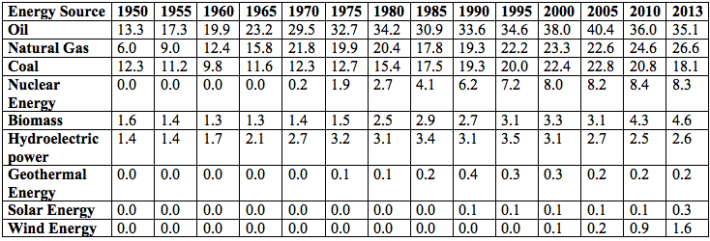

Source: United States Energy Information Administration, Annual Energy Review 2014
Pollution Patrol

Air Pollution
Air is essential to life. The air around us is comprised primarily of the elements nitrogen and oxygen. When other substances such as chemicals, natural materials, or particles enter the air, this is known as air pollution. Air pollution can occur both indoors as well as outdoors. It can have both natural and human induced causes. Air pollution impacts humans, animals and the environment in a number of different ways.
Air pollution can be the result of a number of different types of human activity. When pollutants from smokestacks and automobile emissions are released into the air, chemical reactions occur in the atmosphere which can lead to a number of problems. Smog occurs when pollutants in the air mix with ozone, causing hazy atmospheric conditions and respiratory problems in humans. Smog typically occurs over large cities or industrial areas. London, Los Angeles, Mexico City and Southeast Asia all have significant problems with smog. Acid rain occurs when pollutants such as sulfuric acid mix with water in the air, causing rain and snow to become too acidic. This acidity is very harmful to the environment and as a result kills plants, trees, fishes and animals. When fuels are burned for energy in automobiles, factories, fireplaces and barbecues, tiny particles are released into the air. These particles make up what is known as particulate matter pollution.

Particulate Matter
Pollution caused by particles, also known as particulate matter, consists of a mixture of
small particles and liquid droplets in the air. Particulate matter can include both coarse
particles and fine particles. Coarse particles are larger than 2.5 microns but less than 10 microns in diameter (A human hair is roughly 70 microns in diameter). These can include
smoke, dust, dirt mold and pollen. Fine particles are less than 2.5 microns in diameter. Fine particles can include toxic compounds and heavy metals.

Particulate pollution, particularly fine particle pollution, is very harmful to humans when inhaled. Particulate matter disrupts ecosystems. Particles in the air also cause hazy atmospheric conditions. The amount of particulate matter in the air varies depending on the time of the year and the weather. For example, the amount of particulate matter may be higher in the winter due to an increase in the use of fireplaces and wood burning stoves.

Particulate pollution is also categorized by its source. Primary particles can be traced directly to their sources, such as smokestacks, idling vehicles or power plants. Secondary particles on the other hand, are created through reactions in the atmosphere and are therefore much more difficult to trace.
Particle Matter Samplers and Counters
Particulate matter samplers collect particulate matter to determine how much is in the air
and so that particles may be examined later in a laboratory. One type of particulate matter sampler draws air through a filter attached to a glass tube. The weight of the filter is taken before the sampling occurs. After the filter has collected some particles, it is then weighed again. The amount of particulate matter is calculated using the weight of the particulate matter collected by the filter and the amount of air sampled. Another type of particulate matter sampler collects particulate matter on a reel of filter tape, which is weighed before and after the sampling.

Instruments known as particle counters detect and count the number of particles in the air. Aerosol particle counters count the number of particles in the air and measure their
size. Light blocking particle counters detect the amount of particles in the air by passing light through an air sample and measuring how much of that light is being blocked by the
particles. This method can be used to assess particles that are larger than 1 micrometer.
Smaller particles (larger than .05 micrometer) can be detecting using the light scattering method. This method measures how much light is scattered by particles in an air sample.
Lasers can also be used to illuminate an air sample so the silhouettes of particulate matter can be captured with a digital camera for magnification and examination.

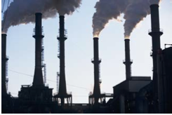
Rating Air Quality
The World Health Organization has established guidelines for air quality based on the negative health effects of pollution on humans. Many countries have established scales that rate the quality of the air in a particular region at a given time. These scales rate air quality based on the concentration of pollutants in the air, but vary by location and also as to which type of pollution they assess. Despite evidence of the negative impact of air pollution on health, many countries still do not monitor and rate air quality.

In Mexico City, the Sistema de Monitoreo Atmosférico de la Ciudad de México (SIMAT) uses a rating system known as Índice Metropolitano de la Calidad del Aire (IMECA) to measure concentrations of pollutants including fine particulate matter, carbon monoxide, sulphur dioxide,nitrogen dioxide and ozone. A 200 point rating scale consisting of five categories ranging from “buena” (good) to “extremadamente mala” (extremely bad) is used to rate and describe air quality conditions. In the United States, the Environmental Protection Agency uses the Air Quality Index which examines concentrations of these same pollutants and assigns a rating on a scale of 0 to 500. Within this scale there are six categories that describe the quality of the air ranging from “Good” to “Hazardous”. The Hong Kong Environmental Protection Department also rates air pollution on a 500 point scale with five categories ranging from “low” to “severe” based on concentrations of pollutants in the air. In March 2010, Hong Kong’s air pollution hit record levels (over 500!) after a serious sandstorm occurred in southern China.

Reading taken from http://www.tryengineering.org/sites/default/files/lessons/pollutionpatrol.pdf
Energy is Blowin’ in the Wind

Purpose: You are a team of engineers who have been given the challenge to design a device that can detect the presence of particulate pollutants outside of your school. The device must have a flat collection area which is at least 5 cm x 5 cm. The device needs to have relative protection away from the elements and should be able to be secured (so it does not blow away).

Step 1: Meet with your group to develop and agree on a design for your air pollution detector. At this time you must determine the materials that your group wants to use. With the people in your engineering team, draw a diagram for your Pollution Device. Be sure to include all the materials that are being used to build your device.

______________________ teacher approval

Once your design is signed off by the teacher, you may begin building.

Step 2: Build your air pollution detector.

During construction did you make any changes to your initial design? (Make sure you record all changes and the rational for your decisions.)

_______________________________________________________________________________________________________________________________________________________________________________________________________________________________________________________________________________________________________________________.

Step 3: Decide where your group will place the detector. (Only one other group may share your same location.)

______________________________ location

Step 4: 72 hours later…Use a hand lens or a microscope to examine what you have collected. Make a detailed drawing of what you have collected and write a description using complete sentences in the box below.

Step 5: Use a string to create a grid of 1 cm squares over your device’s collection area, securing it with tape. Count the number of particles in 5 random squares. Record your data in the table below. Then calculate the average number of particles per square.

Box | Number of Particles
Total number of particles

Average number of particles: (show your work)

Step 6: Share your findings with your class. Fill in the data table below showing others results.
Location | Average Number of Particles
Conclusion:
- Based on our results and the reading, how might you evaluate the air quality/air pollution at the locations tested around your school?

_______________________________________________________________________________________________________________________________________________________________________________________________________________________________________________________________________________________________________________________.
- If you had to do it all over again, how would your planned design change? Why?

_________________________________________________________________________________________________________________________________________________________________________________________________________________________________________.
- What type of particulate pollution did you find the largest quantity of? Why do you think that is?

_________________________________________________________________________________________________________________________________________________________________________________________________________________________________________.
- What do you think can be done to reduce particulate pollution around your school?

_________________________________________________________________________________________________________________________________________________________________________________________________________________________________________.

- Lab adapted from tryengineering.org

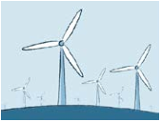
Working with Wind Energy

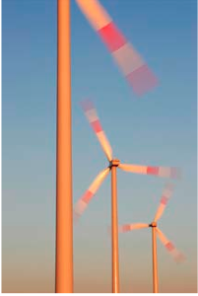
What is Wind Energy?
Wind is a form of solar energy. Winds are caused by the uneven heating of the atmosphere by the sun, the irregularities of the earth's surface, and rotation of the earth. Wind flow patterns are modified by the earth's terrain, bodies of water, and vegetation. Humans use this wind flow, or motion energy, for many purposes: sailing, flying a kite, and even generating electricity. The term "wind energy" describes the process by which the wind is used to generate mechanical energy or electricity. Wind turbines convert the kinetic energy in the wind into mechanical energy. Mechanical energy can be used for specific tasks (such as grinding grain or pumping water) or a generator can convert this mechanical energy into electricity.

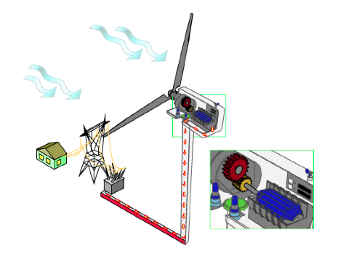
How Wind Turbines Work
A wind turbine works the opposite of a fan. Instead of using electricity to make wind, like a fan, wind turbines use wind to make electricity. The wind turns the blades, which spin a shaft, which connects to a generator and makes electricity. Wind turbines, like windmills, are usually mounted on a tower to capture the most energy. Wind turbines operate on a simple principle. The energy in the wind turns two or three propeller-like blades around a rotor. The rotor is connected to the main shaft, which spins a generator to create electricity. Wind turbines are mounted on a tower to capture the most energy. At 100 feet (30 meters) or more above ground, they can take advantage of faster and less turbulent wind. A blade acts much like an airplane wing. When the wind blows, a pocket of low-pressure air forms on the downwind side of the blade. The low-pressure air pocket then pulls the blade toward it, causing the rotor to turn. This is called lift. The force of the lift is actually much stronger than the wind's force against the front side of the blade, which is called drag. The combination of lift and drag causes the rotor to spin like a propeller, and the turning shaft spins a generator to make electricity. Wind turbines can be used to produce electricity for a single home or building, or they can be connected to an electricity grid (see illustration to the right)
for more widespread electricity distribution.

Wind speed and the height of the blades both contribute to the amount of energy generated. An interactive game from the Danish Wind Industry Association (www.windpower.org/composite-106.htm) lets you explore this concept in a game.

*taken from http://www.tryengineering.org/sites/default/files/lessons/workingwithwind.pdf
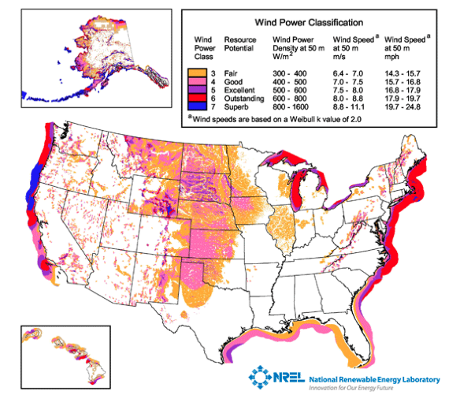
Site Testing for Wind Energy

Not all locations are suitable for wind energy development. They need to be evaluated to determine if the cost associated with installing a wind turbine will likely be balanced by the value of energy generated over time.

One of the first steps to developing a wind energy project is to assess the area's wind resources and estimate the available energy. To help the wind industry identify the areas best suited for development, the U.S. Wind Energy Program works with the National Renewable Energy Laboratory (NREL) and other organizations to measure, characterize, and map wind resources 50 meters (m) to 100 m above ground. At the local level, towns and
contractors will work with homeowners to determine the cost and likely financial benefits of wind turbine installation. Often the first step is to temporarily install an anemometer to test the wind at a farm or home over several months or even a year.
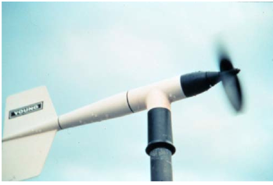
Using Anemometers to Test Wind Potential
An anemometer is a device that is used for measuring wind speed. Many countries and organizations offer anemometer loan programs, so a company or individual can evaluate the wind at their site to determine if enough wind energy would be generated at their location. For these test sites, an anemometer might collect wind-speed data in 10-minute intervals over a long period of time.

Global Wind Day!
There's even a "Global Wind Day" on June 15 of each year to raise awareness of wind energy worldwide. Thousands of public events are organized simultaneously around the world. More information is at www.globalwindday.org.

- Taken from http://www.tryengineering.org/sites/default/files/lessons/workingwithwind.pdf

Blade Options

Blade Design
Blades come in many shapes and sizes, and there is continuing research into which design is best. It turns out that the optimal design really depends on the application, or where and how the blade will be used. Designers look at the "tip speed ratio" that determines efficiency. This is the ratio between the speed of the wind and the speed the blade tip. High efficiency 3-blade-turbines have tip speed/wind speed ratios of between 6 and 7.

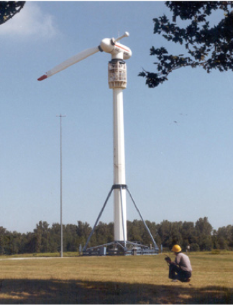
How Many Blades?
Most wind turbines use either two or three blades. Research indicates that as more blades are added there is a increase in aerodynamic efficiency, but this efficiency decreases dramatically with each added blade. For example, increasing the number of blades from one to two can yield a six percent increase in aerodynamic efficiency, but increasing the blade count from two to three yields only an extra three percent in efficiency. And, of course, there are cost implications too. Each additional blade in a design will increase the cost of the end product, so engineers have to factor in both the increased efficiency and the increased cost of manufacturing to determine a design that will be the best for an application. Aesthetics
is also a consideration. A small, two or three blade design might be best for a residential area, where a homeowner just wants to pull from the wind enough energy to power
their own home, and would prefer a quieter option. A giant 12 blade design would not look very nice atop their home and would perhaps generate more energy than they
need, and likely more noise too! To the right you can see how NASA tested a one-bladed rotor configuration. (Photo by NASA Glenn Research Center)

Materials
Early windmills were made of wood with canvas sails. These deteriorated over time and required care – but they represented the materials readily available! More recently, older mechanical turbine blades were made out of heavy steel...but now many are made using fiberglass and other synthetic materials that offer strength at lower weights. And, lower weight building materials can result in larger blades to catch more wind in applications where size and space are less of an issue. Manufacturers also use epoxy-based composites which may offer manufacturing advantages over other materials because the process has less impact on the environment and can result in a smoother surface finish. Carbon fibers have also been identified as a cost-effective method to further reduce weight and increase stiffness. Smaller blades can be made from light metals such as aluminum.
Engineers will be working in this field for years to come to determine the optimal shape, weight, and materials to generate energy most efficiently!
*Taken from http://www.tryengineering.org/sites/default/files/lessons/workingwithwind.pdf
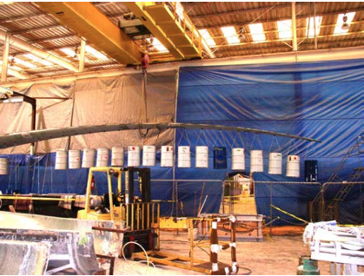
Blade Innovation and Testing

Which Shape is Best?
Turbine blades are made in many different
shapes – and sometimes it is the application
that determines which shape is best. For
example, a wind turbine blade design that
researchers at Sandia National Laboratories
developed in partnership with Knight & Carver of
San Diego, CA promises to be more efficient
than current designs. It should significantly
reduce the cost-of-energy (COE) of wind
turbines at low-wind-speed sites. Named “STAR”
for Sweep Twist Adaptive Rotor, the blade (see
prototype to the right) has a gently curved tip,
termed “sweep,” which unlike the vast majority of blades in current use, is specially designed for low-wind-speed regions like the Midwest of the United States. The sites targeted by this effort have annual average wind speeds of 5.8 meters per second, measured at 10-meter height. Such sites are abundant in the U.S. and would increase by 20-fold the available land area that can be economically developed for wind energy. Sized at 27.1 meters long, it is almost three meters longer than the blades it will replace — and, instead of a traditional linear shape, the blade features a curvature toward the trailing edge, which allows the blade to respond to turbulent gusts in a manner that lowers fatigue loads on the blade. It is made of fiberglass and epoxy resin.

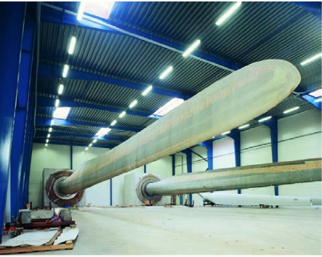
Research and Testing
Before starting production of a new blade
model, a prototype is tried out in a test bed (see
image right courtesy of blade manufacturer LM
Glasfiber. The blade is subjected to a strain
corresponding to 20 years of operation during
the testing process. LM Glasfiber is a good
example of a "component" manufacturer – this
is a business that does not manufacture an
entire product, but focuses on a specific
component – in this case turbine blades. LM
Glasfiber has produced a total of more than
120,000 wind turbine blades since 1978. This
amounts to more than one in three of all the
blades in operation today, worldwide. One of the
company's goals is to develop new technology that makes wind turbines more efficient and extends the service life of both the turbines and the blades. The company points out that "developing new types of blades is based on concrete decisions regarding design, materials and processes. Any adjustment to one parameter also impacts the others." This means that if they test a new shape, they may need to change a material as well.

- Taken from http://www.tryengineering.org/sites/default/files/lessons/workingwithwind.pdf
Renewable Energy: Wind Energy

Do Now: Have you ever seen a windmill in real life? Why would we want to build wind turbines?

Purpose: You are working as a team of engineers who have been given the challenge to design a windmill out of everyday items. Your windmill will need to be able to withstand wind from a fan for at least one minute while winding a string or wire to lift a light object such as a teabag. You are working on a budget and will have to “purchase” materials from your teacher to create your design. You may return materials, exchange materials with other teams, but will need to determine the “cost” of your windmill- the least expensive design that meets the challenge will be considered the most efficient design!

Step 1: Meet with your group to develop and agree on a design for your windmill. At this time you must determine the materials that your group wants to use. With the people in your engineering team, draw a diagram for your windmill. Be sure to include all the materials that are being used to build your device. ** Keep in mind that your design must
be strong enough to withstand the wind from a fan or hairdryer and the base cannot move so it will have to be secured to a table or shelf. **Also remember that you are on a budget**

______________________ teacher approval

Step 2: Build your air pollution detector.

During construction did you make any changes to your initial design? (Make sure you record all changes and the rational for your decisions.)

__________________________________________________________________________________________________________________________________________________________________________________________________________________________________________

Step 3: Test
Remember that each windmill will be tested at the same speed and distance. Your windmill must operate for 1 minute while winding a light object up with a string. Remember if you do not like the way that it moves you can always go back and make changes. You must record all changes! (HINT: watch others test to get ideas)

First test: Setup your windmill and observe how it moves. Record your observations below. (How can you improve your design, did you notice any problems?

_________________________________________________________________________________________________________________________________________________________________________________________________________________________________________.

Things that worked well | Things that did not work

Step 4: Final test (complete the data table)

Was your device able to lift the object? | How long did it take? | Final cost of the windmill

Conclusion:

- Did you succeed in creating a windmill that operated for one minute that could life an object? What made your device successful or not?

- If you had to do it all over again, how would your plan design change? Why?

- How did the most “efficient” design differ from your own?

- What drawbacks does a wind turbine have as a reliable source of energy?

- What advantages does the windmill have as a renewable source of energy?

- Lab adapted from tryengineering.org

Retaining Energy

Focus Question: Which material is the best insulator?

Hypothesis: I think that the _________________ (metal can, Styrofoam cup, glass beaker) will hold heat the best because ______________________________________________________.
Materials: glass beaker, Styrofoam cup, metal can, timer, 3 thermometers, stop watch, plastic wrap, hot water, 12 pieces of paper, 2 rubber bands.

Independent Variable: (what we are changing) | Dependant Variable
Constants (what we are keeping the same)

Table 1: Temperature of water over time

Material | Minutes
 | 0 | 1 | 2 | 3 | 4 | 5 | 6 | 7 | 8 | 9 | 10 | 11 | 12 | 13 | 14

Looking at the table above, what claims can you make about the material used for insulation?

Claims | Evidence
1. _________________ was a better at holding heat than _____________________.  2.  3. | 1.  2.  3.
Retaining Energy Part 2

Focus Question: Does adding extra layers to materials make them better insulators?

Hypothesis: I think that the __________________ (metal can/Styrofoam cup) will hold heat the best because ________________________________________________________________.
Table 2: Temperature of Water Over Time

Material | Minutes
 | 0 | 1 | 2 | 3 | 4 | 5 | 6 | 7 | 8 | 9 | 10 | 11 | 12 | 13 | 14
Styrofoam
Metal

Looking at the table above, what claims can you make about the material used for insulation and the affect the added paper had?

Claims | Evidence
1. _________________ was a better at holding heat than _____________________.  2.  3. | 1.  2.  3.

Graphing

You will now use the data that you collected in data table 2 to create a graph. Remember to use a different color to represent each material.

Remember to number and label your x and y axis!

Conclusion

Which material is best for insulating? (Use the data tables and the graph as evidence to explain.)

What does this tell you about retaining energy?

How can this be applied to buildings?
*adapted from Investigating Earth Systems: Energy Resources

Building an Energy House

Focus Question: What materials will most efficiently insulate your Energy House?

Before you begin:
- Read over the building code
Building code:
- The door must open and close. It must measure at least 5 cm x 8 cm.
- Windows do not have to open but you must be able to see through them. There must be at least 2 windows with a total surface area 16cm².
- The ceiling must be at least 5 cm above the top of the door.
- Insulation on the floor and walls cannot exceed 1.5 cm in thickness.
- No insulation can be exposed. All insulation must be covered by a ceiling, wall or floor.

- Examine the materials available and their cost. As a group, decide which materials you want to use and the amount your group would like to spend. Write them on your Cost Sheet.
- Create a blue print for your Energy House in the space provided below. (Remember to create a scale to ensure accurate measurements.)

- Take your cost sheet and your blue print to your “client”. You will have a presentation meeting to propose your ideas. If your client likes your ideas, then they will sign off on your proposal and you may begin construction.

_______________________________ Client Approval

- Purchase your materials and begin building your house. Remember to follow Building Code! You can purchase additional materials if you need them. Make sure to add them to your cost sheet.

- When your house is finished, fill or obtain a plastic bag with 8 ice cubes. Place the bag flat on the floor of the house and close the house.

- Have your teacher measure and record the temperature of the classroom

__________________ class room temperature

- After 10 minutes, record the temperature of your house at ceiling level by carefully sliding the thermometer into the house through the top of the door, taking care not to allow cool air to escape.

__________________ house temperature

- Find the difference in temperature between your house and the classroom.

- Calculate your energy savings on your Cost Sheet.

*adapted from www.need.org

Cost Sheet

Amount Total Cost

___________ Packing Tape @ $0.50 roll ______________
__________ Styrofoam Tape @ $1.00/50cm ______________
__________ Bubble Wrap @ $1.00/strip ______________
__________ Shredded Paper @ $0.10/90mL(specimen cup filled) ______________
__________ Eye Glass Lens @ $0.05/lens ______________
__________ Plastic Rectangles @ $0.10/each ______________
__________ Clear Plastic Film @ $0.20/5cm ______________
__________ Hot Glue @ $0.05/stick ______________
__________ Yarn/Fuzz (Fiber Glass) @ $0.50/90mL (specimen cup filled) ______________
__________ Denim @ $0.50/strip ______________
__________ Card Stock @ $0.75/sheet ______________
(first 5 are free)

Total Cost for Materials : _____________

- Room temperature ______________

- House temperature ______________

- Difference in temperature ___________

Total savings = [Δ ºC x ($3.00/ºC/year x 10 years)] – total cost for materials

4. Total savings: _________________________

