Physics: Kinematics
The Mouse Trap Car
The following learning activities were backwards planned to facilitate the development of students’ knowledge and skills for mastery of this NGSS Performance Expectation. Not all of the dimensions and CCSS are covered in the following activities and teachers are encouraged to address them where possible.
HS-PS2 Motion and Stability
Students who demonstrate understanding can:
HS-PS2-1. | Analyze data to support the claim that Newton’s second law of motion describes the mathematical relationship among the net force on a macroscopic object, its mass, and its acceleration. [Clarification Statement: Examples of data could include tables or graphs of position or velocity as a function of time for objects subject to a net unbalanced force, such as a falling object, an object rolling down a ramp, or a moving object being pulled by a constant force.] [Assessment Boundary: Assessment is limited to one-dimensional motion and to macroscopic objects moving at non-relativistic speeds.]

The performance expectation above was developed using the following elements from the NRC document A Framework for K-12 Science Education:
Analyzing and Interpreting Data  Analyzing data in 9–12 builds on K–8 and progresses to introducing more detailed statistical analysis, the comparison of data sets for consistency, and the use of models to generate and analyze data.  - Analyze data using tools, technologies, and/or models (e.g., computational, mathematical) in order to make valid and reliable scientific claims or determine an optimal design solution. (HS-PS2-1) |  | PS2.A: Forces and Motion  - Newton’s second law accurately predicts changes in the motion of macroscopic objects. (HS-PS2-1)  *not directly correlated to kinematics |  | Cause and Effect  - Empirical evidence is required to differentiate between cause and correlation and make claims about specific causes and effects. (HS-PS2-1),(HS-PS2-5)*  *not directly correlated to kinematics.
Connections to other DCIs in this grade-band:
HS.PS3.C;, HS.ESS1.A; HS.ESS1.C; HS.ESS2.C
Articulation of DCIs across grade-bands:
MS.PS2.A; MS.PS3.C
Common Core State Standards Connections:
ELA/Literacy -
 |  | RST.11-12.1 | Cite specific textual evidence to support analysis of science and technical texts, attending to important distinctions the author makes and to any gaps or inconsistencies in the account. (HS-PS2-1),(HS-PS2-6)
 |  | RST.11-12.7 | Integrate and evaluate multiple sources of information presented in diverse formats and media (e.g., quantitative data, video, multimedia) in order to address a question or solve a problem. (HS-PS2-1)
 | WHST.11-12.9 |  |  | Draw evidence from informational texts to support analysis, reflection, and research. (HS-PS2-1),(HS-PS2-5)
 | Mathematics -
 | MP.2 |  |  | Reason abstractly and quantitatively. (HS-PS2-1),(HS-PS2-2),(HS-PS2-4)
 | MP.4 |  |  | Model with mathematics. (HS-PS2-1),(HS-PS2-2),(HS-PS2-4)
HSN.Q.A.1 |  |  |  |  | Use units as a way to understand problems and to guide the solution of multi-step problems; choose and interpret units consistently in formulas; choose and interpret the scale and the origin in graphs and data displays. (HS-PS2-1),(HS-PS2-2),(HS-PS2-4),(HS-PS2-5),(HS-PS2-6)
HSA.CED.A.2 |  |  |  |  | Create equations in two or more variables to represent relationships between quantities; graph equations on coordinate axes with labels and scales. (HS-PS2-1),(HS-PS2-2)
HSA.CED.A.4 |  |  |  |  | Rearrange formulas to highlight a quantity of interest, using the same reasoning as in solving equations. (HS-PS2-1),(HS-PS2-2)
HSF-IF.C.7 |  |  |  |  | Graph functions expressed symbolically and show key features of the graph, by in hand in simple cases and using technology for more complicated cases. (HS-PS2-1)
HSS-IS.A.1 |  |  |  |  | Represent data with plots on the real number line (dot plots, histograms, and box plots). (HS-PS2-1)

 | Winding up/ Student walk | Galileo’s Inclined Plane | Galileo’s Free Fall | Video Analysis
Student Experience | Students discuss and evaluate ways to determine the velocity of winding toys. Students experience data set that discusses constant velocity | Students analyze a ball rolling down an inclined plane to gather time and displacement data to produce the acceleration due to gravity. | Students take part in Galileo’s famous falling objects lab to determine the acceleration due to gravity.  (modeling of equation) | Students use cell phone cameras to collect and analyze data.
T4T Material | N/A | balls, vertical blinds, 4 in rings | Any materials that can be dropped. | N/A
Big Idea | $$Velocity=\frac{ΔX}{Δt}$$ | Acceleration  Non constant velocity | $$x=\frac{1}{2}at^{2}$$ | To minimize human error in data points.
Connection to Culminating Activity | Meaning of velocity and procedure for experimentally determining the average velocity from motion. Plotting data. | Students experiment with accelerating objects and changing velocities.  *Video Analysis* | Students learn that objects fall at the same rate due to the acceleration due to gravity. | Scaffold in inclined plane and free fall activity.
CA Standards | Forces & motion 1.a | Forces & motion 1.a | Forces & motion 1.a
Next Generation Science Standards | HS-PS2-1  Crosscutting concepts: Patterns  Science & Engineering practice:  Analyzing & interpreting data  Mathematical/computational thinking  Common Core:  MP.2 , .4  HSN.Q.A.1, .2  HSA.CED.A.2 | HS-PS2-1  Crosscutting concepts: Patterns  Science & Engineering practice:  Analyzing & interpreting data  Mathematical/computational thinking  Common Core:  MP.2 , .4  HSN.Q.A.1, .2  HSA.CED.A.2 | HS-PS2-1  Crosscutting concepts: Patterns  Science & Engineering practice:  Analyzing & interpreting data  Mathematical/computational thinking  Common Core:  MP.2 , .4  HSN.Q.A.1, .2  HSA.CED.A.2
Time | (2) 55 minute class | (1) 55 minute class | (1) 55 minute class | -

 | Culminating Activity – Mouse Trap Car
 | Mouse trap Car Build | Experimenting and Collection Data | Mouse Trap Write Up
Student Experience | Students are introduced to the Culminating Activity (if not done at the beginning of unit)  Students design and carry out the construction of a mouse trap powered vehicle. | Students design and carry out a test to determine the velocity of their vehicle. | Students articulate their findings in a well structured lab write up
T4T Material | One mouse trap (pairs)  The cart | N/A | N/A
Big Idea | Build a functioning car that travels in a line. | Designing a controlled experiment. Thinking about how they will collect data to determine the velocity of their mouse trap car. | Articulate scientific findings. Reporting and interpreting data and graphical representations. Drawing conclusions from scientific method.
CA Standards | ------ | ------- | _____
Next Generation Science Standards | HS-PS2-1  Crosscutting concepts: Patterns  Science & Engineering practice | HS-PS2-1  Crosscutting concepts: Patterns  Science & Engineering practice:  Analyzing & interpreting data  Mathematical/computational thinking  Common Core:  MP.2 , .4  HSN.Q.A.1, .2  HSA.CED.A.2 | ELA Common core:  WHST.11-12.7  WHST.11-12.9  Use of text books and student research to back up experimental data.
Time | Three 55 min period | One 55 min period | Two 55 min periods

Total Time:
(11) 55 minute class periods
*Teacher can adjust pacing for winding up and lab write up based on student needs
Lesson Plans for Winding UP

Prior Knowledge: Students are proficient with the concepts of displacement, time, and velocity

Objective:

SWBAT Choose which data to collect, graph the data, and determine how to analyze the graph to find the average velocity of a wind-up toy (student walk)

Engage & Explore:

- Students predict the velocity of winding toys
  - “Will the toys have a constant velocity? Why or why not?
  - Students predict the motion graph.
- Students determine what data is needed to determine the motion
  - Displacement
  - Velocity
- Students devise an experiment to determine the data to graph the motion.
- Students collect data
  - Students organize and perform an experiment to determine displacement and time
- Students interpret their data
  - Students plot their data & “connect the dots”
- Students draw conclusions
  - Does the data set demonstrate constant velocity?
  - What is your evidence for making this conclusion?
Explain & Elaborate
- Teacher facilitates a class discussion on graphing
  - “How should graphs look?”
    - Students are led in a Q&A discussion on the purpose of graphs
    - Students will understand the purpose of graphing and their function is interpreting data.
  - “What does these data mean?
    - Students will learn to draw conclusions from their lab data
      - Respond to and interpret slopes
      - Understand the meaning of slope in position and time plots
      - Line of best fit and calculating velocity
Evaluate
- Students analyze position versus time plots.
  - Is the object moving away, moving towards initial position, or at rest?
    - Students interpret slopes and direction of velocity
    - Students are able to provide evidence for their responses.
2. Galileo’s Incline Plane

Objective:

SWBAT to create an experiment to interpret motion of accelerating objects

Engage and Explore
- Students devise an experimental procedure to determine the velocity of balls rolling down an incline
- Students predict the velocity of rolling marbles
  - “Will the marbles have a constant velocity? Why or why not?
  - “What will the motion on a graph look like?
- Students collect data
  - Students organize and perform an experiment to determine displacement and time
  - Displacement is measure on the incline of the ramp!
- Students interpret their data
  - Students plot their data & “connect the dots”
- Students draw conclusions
  - Does the data set demonstrate constant velocity?
  - What is your evidence for making this conclusion?
  - Why do you think this occurred?

Explain & Elaborate
- Students make observations from their plots
  - What trend do you see in this graph?
  - Students ought to draw conclusion that elevation affects the velocity of objects
    - Students may or may not be able to attribute their findings to the acceleration of gravity

Evaluate

- Students analyze position versus time plots.
  - Is the velocity increasing, decreasing, or constant?
    - Students interpret slopes and direction of velocity
    - Students are able to provide evidence for their responses.

3. Galileo’s Falling Objects
Objective:

SWBAT devise an experiment to analyze the acceleration of falling objects

Engage and Explore:
- Students devise an experiment to collect data to determine the acceleration of a falling object
- Students make predictions
  - “Which object will hit the ground first?”
  - “What evidence can you present to support this prediction?”
- Students collect data
  - Students design and perform an experiment to determine Displacement and Time
- Students interpret their data
  - Students use $X=\frac{1}{2}*at^{2}$ to calculate the acceleration of their objects
  - Students plot their data in a displacement versus time plot
- Students draw conclusions
  - “Does the data set demonstrate constant velocity?”
  - “What is your evidence for making this conclusion?”
  - “What conclusion can you draw about falling objects?”

Explain & Elaborate
- Students compare the two projects
  - Students look at data from their inclined plane and falling objects
  - Students draw conclusions on similarities and differences between the two experiments.
Evaluate
- Students perform a problem set to identify graphs (x vs t) and (v vs t) and to identify the direction and type of motion (i.e. moving away from initial position, at rest, accelerating, decelerating etc.)

4. Culminating Activity – Mouse Trap Car

Engage
- Students construct mouse trap cars using materials from T4T
  - Students are introduced to the materials & objectives that should be met for the build
  - Teacher may provide restrictions on outside materials that may be used (optional)
  - Safety considerations should be addressed.
Explore and Explain
- Students devise an experiment to determine the velocity of their mouse trap cars
  - Teacher should oversee their procedures to determine if they are sufficient to collect data
- Students make a prediction about the velocities of their cars
- Students collect data
  - Students carry out their procedure and collect displacement and time data to analyze their cars
  - Students perform the experiment 2 to 3 times to gather more accurate results
- Students analyze their data
  - Plot their data
  - Calculate the velocity values
- Students draw conclusions from their data

Elaborate & Evaluate
- Students will prepare lab write up
  - Students will present all of their lab from the explore and explain above in a well structured lab write up

*During all activities teacher serves as a facilitator of student learning (i.e. student centered instruction). Most tasks should be completed by students after simple directions, or facilitated questions to enhance student learning.

Accommodations
All individual accommodations for students should be met with respect to your particular students and classroom dynamics and will vary from class to class and group to group. Facilitator should always differentiate instruction by providing the necessary blend of guidance and exploration for each student group and their specific needs.

Winding Up/ Student Walk
Predict. . .

Will the motion be a constant velocity? Why or why not?

How will the graph of this motion appear? Sketch your prediction in the space below

Test. . .

What data do you need to collect to determine the motion? Explain

Devise an experiment to gather the data you need to determine the motion. Provide your procedure below

Analyze . . .

Plot the data on a displacement versus time plot on a separate piece of graph paper.

Conclude. . .

Does the data set demonstrate constant velocity?

What is your evidence for making this conclusion?

Do the results match your prediction? Why or why not?

Galileo’s Inclined Plane
Predict . . .

Will the marbles have a constant velocity? Why or why not?

How will the graph of this motion appear? Sketch your prediction in the space below

Test . . .

Create and carry out an experiment to collect data points to determine the motion of a marble down a ramp.

Analyze. . .

Plot your data points on a displacement versus time plot on a separate piece of graph paper.

Conclude. . .

Does your data set demonstrate constant velocity? Explain

Use your plot as evidence to explain why you concluded that your data set is or is not constant velocity.

Why do you think the results occurred? Use your experiment as evidence in your discussion.

Galileo’s Falling Objects
Predict . . .

Which object will hit the ground first?

What evidence can you present to support your prediction?

Test. . .

Devise and conduct an experiment where you can determine which object hits the ground first. Then carry out an experiment to determine the rate of acceleration for the falling objects.

Analyze . . .

Calculate the acceleration of the falling objects and plot your data points on a displacement versus time plot on a separate sheet of paper.

Conclude. . .

Does the data set represent constant velocity? Why or why not?

What conclusions can you draw about falling objects?

Mousetrap Car

This culminating activity will provide all of you the opportunity to design and engineer a car that is powered by a mouse trap. In your groups you will use this car to conduct an experiment and analyze the motion of your vehicle. Additional competition will be held and a winner will be selected based on the car that achieves the greatest displacement.

The project will also include a budgeting plan for selecting materials. Each material will have a specific “cost” associated with it. The idea of a budget is to provide you with the opportunity to realistically problem solve and engineer with financial and resource limits that are often associated with engineering in society.

What are you to do?

THE MOUSETRAP: RE-ENGINEERED
  - Design/Retrofit a mousetrap ergonomically so that it is safe and easy to use if it were to close on your fingers.
  - Use T4T materials to complete the challenge.
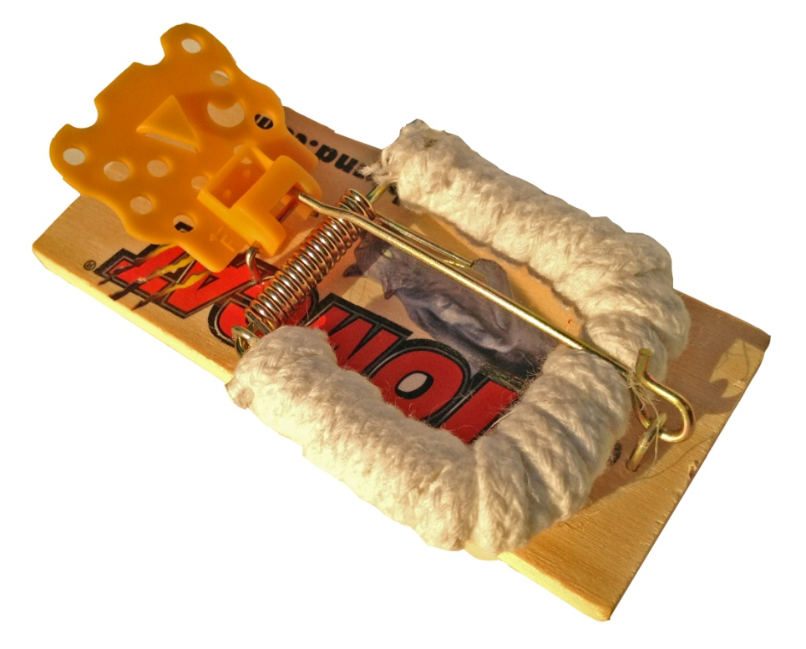
An example of an ergonomic re-design is pictured below using a T4T draw string – creative new designs will earn additional points for this portion of the project.

THE CAR!

- With your team design, sketch, and plan a mousetrap powered vehicle that meets the object of the assignment (within budget & can be powered by a mousetrap to achieve data for experimentation)
- Build the designed mousetrap car. *Please note: no pre-purchased cars may be used and assembled for assignment credit; they must be built using materials from the T4T bins.
- Keep track of your budgeted materials in a designated sheet of paper (provided)
THE EXPERIMENT/ COMPETITION!
- Conduct an experiment using video analysis to gather data points to determine the motion of your car.
- What data will you need to be successful?
  - Initial & Final position
  - Total time
  - Initial & Final velocity
  - Average velocity
  - Initial acceleration (the speed up)
  - Final acceleration (the slow down)
- REMEMBER! Experimentation follows the scientific method. Be certain to include prediction (hypothesis), procedure and data collection (test), analysis, and conclusion.
LAB WRITE-UP!
- Present your build process and experiment in a well developed lab write up.

Date | Material | Withdrawal | Deposit | Balance
 | -

How a Lab Write up Should Look

Your name
Group Members names
Location lab was done
Date the lab was done

Abstract:
This is a summary of your lab! Tell the reader the purpose of the lab, describe the lab, and tell the conclusion to the lab. The abstract should be 3-5 sentences.

Introduction: (in paragraph form!)
- Give the reader background knowledge
  - Give previous scientific research
  - Equations, theories etc
- Tell the reader why this lab is important
- State what you are going to accomplish in the lab
Materials & Methods: (done in list)
- Write Hypothesis: then tell the reader your hypothesis
- Make a list of the materials & supplies used
- Make a list of your procedure
  - The steps you took to do your lab!
  - Mention any and all safety concerns
Results & Discussion: (paragraphs, data tables, and plots)
- State your observations during the lab
- Insert your data table(s) and answer guided questions from the lab hand out
- Make plots and describe what the plots show you
  - Make sure you include labels on your plots

Conclusion:
- Tell the reader if your data makes sense. Why or why not?
- Tell the reader of any mistakes you made during the lab that contributed to errors
- Does the conclusion agree or disagree with your prediction
  - What did you learn from this lab?
- What changes would you make if you repeated the lab?
  - To your procedure and or the lab itself.
**** Suggestions for a good grade
- Always use size 11 or 12 font!
- Titles and section headings may be bolded and/or 14 size font
- Use a simple font (Calibri body, or Times New Roman)
- Include the information in the correct areas
- Do not leave anything out!
- Be organized, label plots and data tables
- Use the computer at all times except for hand calculations or on specific plots as directed. These should be attached in the back of the lab report in an “appendix”

Video Analysis Guide

This guide is meant to help with the technology aspect of the video analysis portion of the unit. It is important to note that the instructor should scaffold the process with students, and students can practice within the inclined plane and/or the free fall activity prior to the mouse trap car analysis. A way to determine position is required to appear on the video while doing the video analysis. Please take this into account during scaffolding with students.

Why Video analysis?

The essence of the video analysis is to provide students with the opportunity to use technology they carry daily in a way that is meaningful to classroom endeavors. Students will use cell phone cameras to assist in collecting data necessary for their labs. Students will use their phones to record specific motions in each lab by using a visible scale on the video. Students can match specific positions to their designated time through the use of video analysis. This data will be used to proceed with the desired lab outcomes.

How to accomplish video analysis:

- Set up a measurement scale for position. Make sure this scale is easily identified via camera. It helps to try video of the scale to determine clarity of the scale.
- Students perform lab procedure as desired by the designated activity. They film the lab with their cell phones.
- Upload the video to a computer and use windows media player to replay the video.
- Once in windows media player the time scale is only measured in seconds. In order to be more precise, the video must be slowed to a frame by frame. This process is described below.
- Students can pause the video at several positions and record the necessary position and time data.
- This data is then used to continue the lab process as developed.
Viewing and moving Frame by Frame

- Open Windows Media Player
- Click “view” in the tool bar or right click the video
- Go to Enhancements
- Go to Play Speed Settings
- Use the next/back buttons to advance/regress video frame by frame
*Most videos are 30 fps, that is 1 frame is 1/30 s

