Physics: Forces
Glider Engineering
The following learning activities were backwards planned to facilitate the development of students’ knowledge and skills for mastery of this NGSS Performance Expectation. Not all of the dimensions and CCSS are covered in the following activities and teachers are encouraged to address them where possible.
HS-PS2 Motion & Stability: Forces & Interactions
Students who demonstrate understanding can:
HS-PS2-1. | Analyze data to support the claim that Newton’s second law of motion describes the mathematical relationship among the net force on a macroscopic object, its mass, and its acceleration. [Clarification Statement: Examples of data could include tables or graphs of position or velocity as a function of time for objects subject to a net unbalanced force, such as a falling object, an object rolling down a ramp, or a moving object being pulled by a constant force.] [Assessment Boundary: Assessment is limited to one-dimensional motion and to macroscopic objects moving at non-relativistic speeds.]

The performance expectation above was developed using the following elements from the NRC document A Framework for K-12 Science Education:
Planning and Carrying Out Investigations  Planning and carrying out investigations to answer questions or test solutions to problems in 9–12 builds on K–8 experiences and progresses to include investigations that provide evidence for and test conceptual, mathematical, physical and empirical models.   Plan and conduct an investigation individually and collaboratively to produce data to serve as the basis for evidence, and in the design: decide on types, how much, and accuracy of data needed to produce reliable measurements and consider limitations on the precision of the data (e.g., number of trials, cost, risk, time), and refine the design accordingly. (HS-PS2-5) |  | PS2.A: Forces and Motion   Newton’s second law accurately predicts changes in the motion of macroscopic objects. (HS-PS2-1)  ETS1.A: Defining and Delimiting Engineering Problems   Criteria and constraints also include satisfying any requirements set by society, such as taking issues of risk mitigation into account, and they should be quantified to the extent possible and stated in such a way that one can tell if a given design meets them. (secondary to HS-PS2-3)  ETS1.C: Optimizing the Design Solution   Criteria may need to be broken down into simpler ones that can be approached systematically, and decisions about the priority of certain criteria over others (trade-offs) may be needed. (secondary to HS-PS2-3) |  | Cause and Effect   Empirical evidence is required to differentiate between cause and correlation and make claims about specific causes and effects. (HS-PS2- 1),(HS-PS2-5)   Systems can be designed to cause a desired effect. (HS-PS2-3)  Systems and System Models   When investigating or describing a system, the boundaries and initial conditions of the system need to be defined. (HS-PS2-2)  Structure and Function   Investigating or designing new systems or structures requires a detailed examination of the properties of different materials, the structures of different components, and connections of components to reveal its function and/or solve a problem. (HS-PS2-6)
Connections to other DCIs in this grade-band:
HS.ESS3.A
Articulation of DCIs across grade-bands:
MS.PS3.A ; MS.PS3.B ; MS.ESS2.A
Common Core State Standards Connections:
ELA/Literacy -
WHST.9-12.2 | Write informative/explanatory texts, including the narration of historical events, scientific procedures/ experiments, or technical processes. (HS-PS2-6)
Mathematics -
MP.2 | Reason abstractly and quantitatively. (HS-PS3-3)
MP.4 | Model with mathematics. (HS-PS3-3)
HSN.Q.A.1 | Use units as a way to understand problems and to guide the solution of multi-step problems; choose and interpret units consistently in formulas; choose and interpret the scale and the origin in graphs and data displays. (HS-PS3-3)
HSN.Q.A.2 | Define appropriate quantities for the purpose of descriptive modeling. (HS-PS3-3)
HSN.Q.A.3 | Choose a level of accuracy appropriate to limitations on measurement when reporting quantities. (HS-PS3-3)

Physics –Forces – The Glider Project

 | Mystery (inertia) Stations  (Newton’s 1st) | Carts & Masses  (Newton’s 2nd) | Force Meters  (Weight &  Hooke’s Law)
Student Experience | Students visit various inertia demonstrations around room, and must determine what they all have in common (concept of inertia is not discussed until end of lesson). | Students attach various masses to a string connected to a cart. The mass falls, students determine the acceleration of the cart, and discover the relationship between force, mass, and acceleration. | Students create their own force meters using an elastic material (from the T4T cart) and calibrate them by hanging known masses.
T4T Material | Bowling ball, table tennis ball, pennies, tablecloth, dishes | T4T cart, string, set of weights | Elastic material from cart, vinyl window blind, set of weights
Big Idea | Newton’s 1st Law.  An object in motion will continue in motion with constant velocity unless acted upon by a net external force. | Newton’s 2nd Law.  F_{net} = ma. | Weight: F_{g} = mg  Hooke’s Law: F_{s} = -kx  (honors physics only)
Connection to Culminating Activity | The glider’s inertia causes its resistance to acceleration when launched. | A net external force on an object will cause it to accelerate, which explains the glider’s acceleration during launch. | The force meters are essentially scaled-down versions of the glider launcher that will be used in the culminating project.
CA Standards | PH1. b. | PH1. c. | --
Next Gen. Sci. Standards | -- | HS-PS2-1. | --
Time | One 55-min period | Two 55-min periods | One 55-min period

CA Standards:

PH1. b. | Students know that when forces are balanced, no acceleration occurs; thus an object  continues to move at a constant speed or stays at rest (Newton’s first law).
PH1. c. | Students know how to apply the law F = ma to solve one-dimensional motion problems that involve constant forces (Newton’s second law).
PH1. d. | Students know that when one object exerts a force on a second object, the second object always exerts a force of equal magnitude and in the opposite direction (Newton’s third law).

 | Tug-of-War  (Newton’s 3rd) | Force Stations  (FBDs) | Glider Engineering  (Culminating Activity)
Student Experience | Students use their force meters to investigate systems where forces oppose each other. They predict force meter readings before testing. | Students visit stations around the room and “draw the forces.” Then, FBDs are introduced, and students create correct FBDs for each system. | Students create a glider to be launched by a rubber band or gravity-driven launcher. The glider must achieve a minimum launch velocity, but avoid too great an acceleration (so the “pilot” doesn’t black-out). If using rubber band, teacher provides students with average force exerted by the launcher.
Material | Student-made force meters. | T4T cart materials, simple machines. | T4T cart materials
Big Idea | Newton’s 3rd Law.  F_{A,B} = –F_{B,A} | Free-body diagrams help depict the forces acting on a system. | F_{net} = ma  v² = v₀² + 2a∆x
Connection to Culminating Activity | -- | Students will create a FBD of the glider-catapult system. | --
CA Standards | PH1. d. | -- | --
Next Gen. Sci. Standards | -- | -- | HS-PS2-1
Time | One 55-min period | One 55-min period | Five to eight 55-min periods

Activity Guide for Forces Unit
Prior Knowledge:
- Students know how to solve problems that involve constant speed and average speed. (v = ∆x/∆t)
- Students know how to solve problems that involve constant acceleration and average acceleration
(a = ∆v/∆t)
- Students know how to solve for the acceleration a of an object starting at rest (v₀ = 0) and traveling a given distance ∆x for an amount of time t. (Use ∆x = v₀t + ½ at².)
- Students know how to solve for the final velocity v of an object starting at rest (v₀ = 0) and undergoing a constant acceleration a for a distance ∆x. (Use v² = v₀² + 2a∆x.)
- Students know that a gravity will accelerate a falling object at 9.8 m/s² .

- Mystery (Inertia) Stations
Objective: Students can articulate the effect of an object’s inertia on its resistance to changes in its state of motion by writing a paragraph detailing observations made at the “Inertia Stations.”

Engage
- Students are introduced to the “Mystery Stations,” and are told that they are designed to illustrate a central concept in physics. Their objective is to identify what they all “have in common.”
Explore
- Students visit the stations in Table 1 and write a brief prediction of what they think will happen prior to actually performing the activity.
Activity | Description
Shake it | Students shake a bowling ball, then shake a table-tennis ball
Tower of washers | Students quickly slide a playing card back and forth against a tower of stacked washers, knocking the bottommost washer out, leaving the tower standing.
Pennies on elbow | Students place a penny on their elbow in front of them, then quickly pull their elbow away and snatch the penny from the air (Figure 1). Students may stack multiple pennies and engage in a class-wide competition to see who can catch the most amount of money.
Tennis ball hat | The tennis ball hat has a tennis ball on each end of a cut and bent wire hanger (Figure 2). The wire balances on a student’s head, enabling the student to spin around while keeping the tennis balls stationary.
Tablecloth trick | Students perform the classic tablecloth trick, where the tablecloth is quickly removed from beneath a place setting of dishes, leaving the dishes safely in place.
Egg (or ball) into beaker | An egg (or ball) is placed on top of a cardboard tube stand, sitting on top of a TupperWare cover (it’s important that is has a lipped edge). The Tupper-Ware cover is flicked away, which knocks the tube out of the way, allowing the egg to fall safely into the beaker of water (Figure 3).
Crash test | A figurine is placed on top of a cart. The cart and figurine is set in motion towards a short wall. When the cart hits the wall, the figurine continues in motion.
Table 1
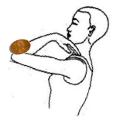  Figure 1. Student places penny on elbow, then quickly pulls elbow away to snatch the penny from the air. | 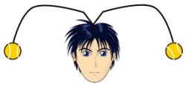  Figure 2. The tennis balls are positioned below the wire hanger’s contact point on the student’s head, allowing the student to rotate while keeping the ball hat balanced. | Figure 3. When flicked horizontally, the TupperWare lid knocks the marker out of the way, allowing the egg to land safely in the beaker of water.

Explain
- When all stations have been visited, students write a paragraph that explains what they all have in common.
Evaluate
- Teacher leads discussion that pushes students towards the statement of Newton’s 1st Law and the term inertia.
Elaborate
- Students write a revised explanation of what the stations have in common, using the term inertia and phrases from the statement of Newton’s 1st Law.
- Students watch “Target Shopping Cart Accident” <http://www.youtube.com/watch?v=xl1PUVOeWp8>, and pretend that they work for an insurance company handling Target’s claim for the accident. They must write a paragraph to their manager (their teacher), explaining what happened and why. Students must reference Newton’s 1st Law and use the term inertia, but explain in such a way that a non-physics student would understand.

- Carts & Masses
Objective: Students will design and conduct an experiment using carts and masses to discover the relationship between force, mass, and acceleration.

Engage
- Students are informed that they will construct gliders to be launched from a catapult. But not yet–at this point in time, they are going to design an experiment to determine what happens to an object when there’s a net force acting on it.
- Show students video footage of airplanes being catapulted from aircraft carriers.
Explore
- Students are shown the experimental setup (Figure 4).
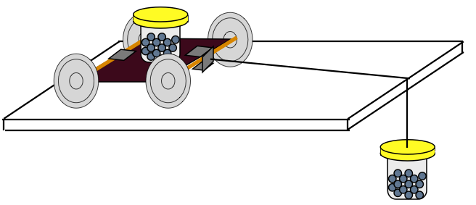
Figure 4. Experimental setup for cart & mass activity

- Students respond to the following questions, and provide an explanation for their thoughts:
  - What will happen to the cart when there is a force applied to it?
  - What if the applied force is increased? What about the cart’s motion will change?
  - What if the cart’s own mass is increased? How will its motion change?
- Have students design and execute experiments to test their hypotheses (at least 5 trials for each hypothesis). At this point in the course, students may or may not have been taught experimental design.

Explain
- Have students graph the data in a way that makes sense to them and have them explain what knowledge they can gain from the data.
Elaborate
- Guide students to analyze their experiments by asking the following questions (class discussion):
  - Why is it a good idea to do multiple trials?
  - What “aspects” were the same from one trial to the next?
    - …We call these factors “constants”
  - What “aspects” changed from one trial to the next?
    - … We call these factors “variables” (they vary)
  - What variable did you change on purpose?
    - …We call this the “independent variable” since you’re free to set it to be whatever you want
  - What variable changed as an effect of changing your independent variable?
    - …We call this the “dependent variable” since its value depends on what your independent variable is
- Guide students towards Newton’s 2nd Law:
  - What happens if we apply a net force on an object?
    - …it accelerates (Although students who make this claim are correct, they must be able to support it with evidence. Acceleration is not measured directly with meter sticks and stop watches, so they must decide what data to collect in order to show that the acceleration changes in direct relation to an applied net force.)
  - What happens if that net force is increased?
    - …its acceleration increases
  - What happens if the mass of the object itself increases?
    - …its acceleration decreases
- We have a mathematical expression for this: F_{net} = ma.
Evaluate
- Teacher should give a problem set on F_{net} = ma.

- Force Meters
Objective: Students construct rubber band force-meters to aid in the investigation of forces and Newton’s 3rd Law.
Figure 5. Rubber band force-meter
Engage
- Show a brief clip of astronauts walking (bouncing) on surface of the moon: <http://www.youtube.com/watch?v=16D0hmLt-S0?>.
  - Ask, “Why do objects weigh less on the moon?”
    - Because there is “less gravity”
  - “So gravity is one factor that affects how much an object weighs. What else determines the weight of an object?”
    - The amount of “stuff,” or matter, it’s made up out of. We call this quantity mass.
Explore
- Ask, “How can we use a rubber band to actually determine the weight (the force due to gravity) of an object?” Guide students towards building the rubber band force-meter.
Explain
- “In order to actually put numbers on our force meters, we have to know the formula for figuring out the amount of gravitational force F_{g} from a certain amount of mass m.”
- The formula is F_{g} = mg (or W = mg)
Elaborate
- Ask, “How is this related to Newton’s 2nd Law, F_{net} = ma?”
  - For an object falling under the influence of gravity, the net force is its weight F_{g}, and its acceleration is simply its acceleration due to gravity g (neglecting air resistance).
Evaluate
- Students should now create an accurately labeled scale on their force-meters, displaying the applied force in units of Newtons.
- Teacher should give a problem set on F_{g} = mg.

- Tug-of-War
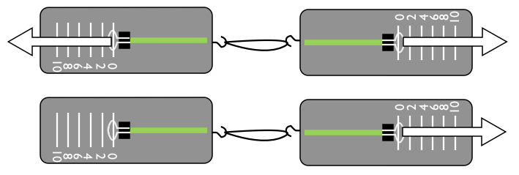
Figures 6 (a) and (b): A student and a partner each pull on the opposing force-meters and observe that they show the same reading. In the second scenario, one student holds his force-meter still, while the partner pulls his force meter to the right.
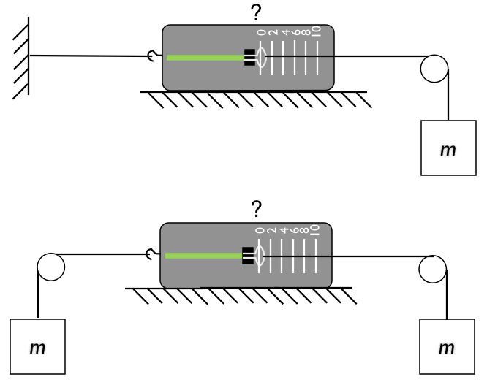
Figures 7 (a) and (b): Students predict the reading on the force meter in each of the two scenarios depicted prior to testing.
Engage
- Demonstration: two students on skateboards (or in roller skates, or sitting in rolling chairs) push off of each other. Then, student A pushes off of student B, and vice-versa. Students predict what they think will happen prior to the demonstration. Encourage students to apply their knowledge of Newton’s 2nd Law to defend their ideas.
- Ask students why they think that it doesn’t matter who does the pushing.
Explore
- Students attach their force-meters with rubber bands or string and record…
  - the reading on each force-meter when both students pull (Figure 6 a.)
  - the reading on each force-meter when one student keeps his force-meter stationary while the other student pulls (Figure 6 b.)
Explain
- Teach mini-lecture on Newton’s 3rd Law.
Elaborate
- Students write predictions for the force-meter readings for each of the two scenarios in Figure 7.
- Students test their predictions, and teacher guides class discussion surrounding the results.
Evaluate
- Teacher should give homework assignment to provide students with practice articulating Newton’s 3rd Law.

- Force Stations
Objective: Students are introduced to free-body diagrams (FBDs), and must create accurate FBDs of physical systems at stations around room.

Engage
- Students watch discovery channel video clip on the physics of skydiving (~3 min.): <http://www.youtube.com/watch?v=ur40O6nQHsw> . In the video, overlaid arrows represent forces on the skydiver’s body. Students are told that they, too, will depict forces using arrows.
Explore
- Students rotate around force stations in the room and explore each system
  - Students identify the labeled station
  - From their analysis of the station, they attempt to draw all the forces on the body of interest
    - Object at rest on table
    - Cart rolling across table
    - Object hanging by string
    - Object hanging by two strings at an angle to each other
    - Ball rolling down ramp
    - Object stationary on ramp
    - Ball falling through air
    - Coffee filters falling through air
Explain
- Teach mini-lecture on FBDs
- Students revise any force station FBD that is incorrect
Elaborate
- Students cut out picture from magazine (which they brought into class earlier in the week) that shows an interesting physical scenario.
- Students create FBD for one or multiple objects in the cutout picture.
Evaluate
- Give homework assignment on FBDs (“Free-Body Exercises: Linear Motion” from The Physics Teacher is included at the end of this activity guide).

- Culminating Activity—Glider Engineering

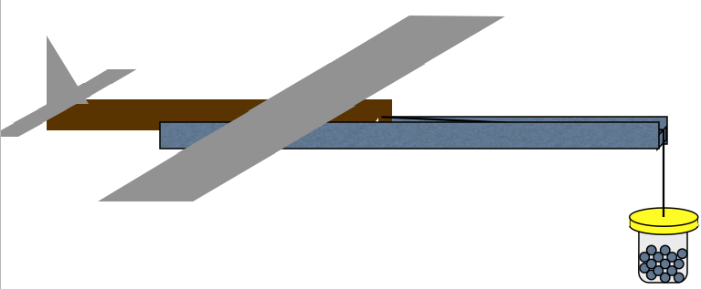
Figure 8: Glider & gravity-driven catapult launch system
Engage
- Introduce the culminating activity (if not done at the beginning of the unit). Inform students that they are going to play the role of aeronautical engineers. The objective is to design and build a glider that will travel the greatest distance from a catapult. Red Bull Flugtag videos may be shown for inspiration: <https://www.youtube.com/watch?v=5Im8VtLQgh4>
- Students read New York Times article, “Navy Has Catapult to Launch Planes,” from 1921
Explore
- Making the glider fly
  - Have students build paper airplanes to get a feel for some of the basics of glider construction.
  - Ask, “What affects how the airplane flies?”

Explain
- Teach mini-lesson(s) on fundamentals of flight
  - Lift, drag, weight, propulsion
  - Yaw, pitch, roll
- Ask students, “Given the objective of the project and the constraints, what are the most important aspects of the glider’s design? How will you develop tests to scientifically work towards the best glider design possible?”
Elaborate
- Glider engineering & testing
  - Students design their gliders in their journals
  - Students construct their glider
  - With their teams, students devise an experiment to determine the optimal design of a single aspect of the glider (e.g.: vary the position of the wing, the angle of the ailerons, the angle of the elevators, the height of the vertical stabilizer, the mass on the glider’s nose, etc.)
  - Prior to running the experiment, students should write a prediction for the outcome of their tests in their journal, as well as an experimental procedure

Evaluate

- Design Report I
  - Students must successfully answer the following questions in order to be green-lighted for the glider launch competition
Design Questions:
- What experiment did you conduct to improve upon your glider’s design?
- Why was this experiment important or worthwhile?
- What was the outcome of your experiment, and how did your findings help to justify your design decisions? (Include all data tables, graphs, etc.)

Analysis Questions:
- If a constant net force of 25 N is applied to your glider, what will be its acceleration?
- At the acceleration determined in #4, what will be the glider’s speed after traveling 1.5 m along the catapult? Assume that the glider starts from rest.
- At the launch speed determined in #5, how far will the glider travel in 2.0 s of flight? Assume that the glider travels in a straight line, and that air resistance is negligible.
- The glider’s pilot is known to lose consciousness during an acceleration greater than 4.0g. According to your expected acceleration during launch, will your pilot survive?

Free-Body Diagrams
Provide a FBD for your glider in each of the following scenarios:
- The glider in the catapult, being held back by a pull (prior to launch)
- The glider accelerating along the catapult, before taking flight
- The glider flying through the air (include drag)
- The glider at rest on the ground

- Teacher facilitates the glider launch in a safe location

- Design Report II
- Students add to their original design report by reflecting on the performance of their glider in the competition
- Teacher may incorporate additional analysis requirements for the report

Honors Physics Addendum: Students should determine the ratio of lift force to drag force through an analysis of the glide angle (Figure 9). The tangent of the glide angle is equal to the ratio of the vertical distance to the horizontal distance covered by the glider. The free-body diagram of the glider reveals that the tangent of the glide angle is also equal to the ratio of drag to lift forces. Video analysis can yield an accurate measurement of the glide angle.
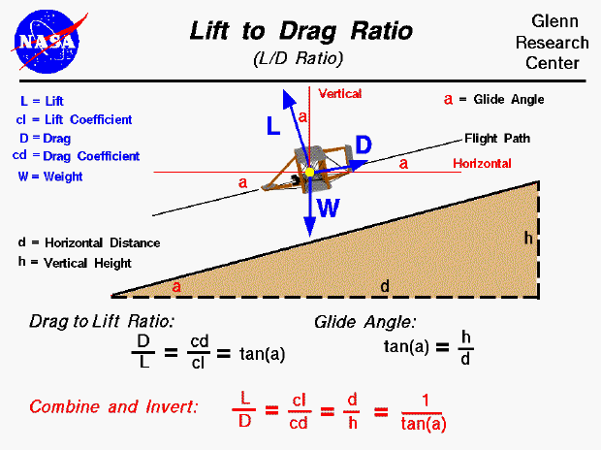
Figure 9: Lift to Drag Ratio as determined through analysis of glide angle.

*During all activities teacher serves as a facilitator of student learning (i.e. student centered instruction). Most tasks should be completed by students after simple directions, or facilitated questions to enhance student learning.
**Use of student handouts serves as guidelines for students.
Accommodations
All individual accommodations for students should be met with respect to your particular students and classroom dynamics and will vary from class to class and group to group. Facilitator should always differentiate instruction by providing the necessary blend of guidance and exploration for each student group and their specific needs.
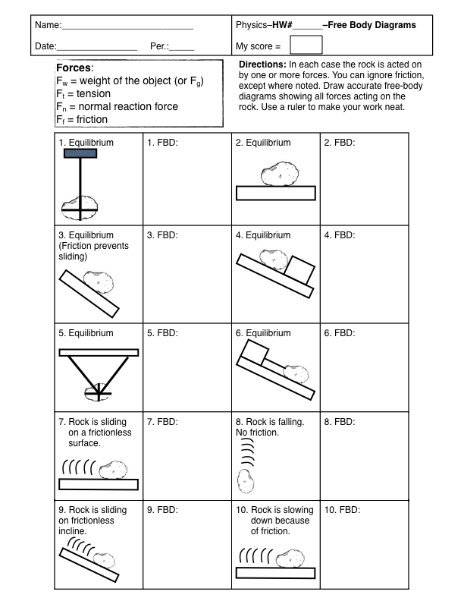
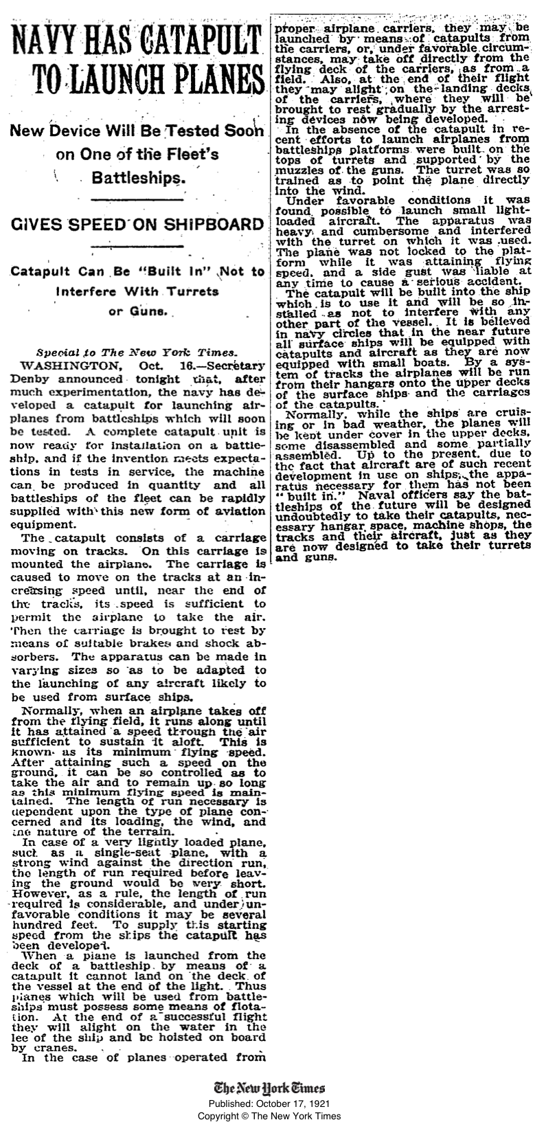
Glider Engineering Project
Project Due Date: ___________________
A glider is an aircraft that lacks an engine and is heavier than air. In this project, you are an aeronautical engineer who must design and build a glider to travel the greatest distance when launched from a catapult. Engineering a glider requires several steps and lots of responsibility. You must (1) create a preliminary design, (2) construct a glider to experiment with, (3) then run tests where one aspect is changed at a time and its effect is recorded. Once your design is optimized, (4) you will submit a technical report that explains your design, experiments, and analysis. Lastly, (5) you will compete against other teams in a class-wide gliding competition. Each step has specifics that you will have to meet in order to move on to the next step and earn full points. Most materials are available from your teacher and excess should be returned.

1. Preliminary Glider Design
Design your glider to meet these minimum criteria:
- Your glider must have a sturdy fuselage (main body) that will enable proper launch from the catapult
- Your glider must be at least 12” in wingspan and length
- Your glider must have at least one variable design characteristic (See 2. Glider construction for more information)

2. Glider Construction
You must build a glider that allows one aspect of it to be changed at a time. For example:
- Variable wing position: The main wing can slide forward or backward along fuselage
- Variable weight capability (ballast): The glider’s mass can be increased or decreased with ease
- Variable center of mass: The center of mass of the glider can be changed by moving the mass
- Variable wing characteristics: The angle of the ailerons, elevators, or flaps can be changed

3. Testing Phase
With your team, you must devise an experiment that will seek to determine the effect of varying a single aspect of the glider’s design. This will allow you to optimize the design of your glider prior to the competition.
- You must plan your experiment before you begin–be sure to write out an experimental procedure
- Keep all aspects of the glider constant except for the single variable which you’re changing each trial
- Record accurate data, observations, and any other notes you think will be important to your design report

4. Design Report
As an aeronautical engineer, it is essential that you are able to communicate the important aspects of your design to others. You must write a technical report that answers the following questions:
Design Questions:
- What experiment did you conduct to improve upon your glider’s design?
- Why was this experiment important or worthwhile?
- What was the outcome of your experiment, and how did your findings help to justify your design decisions? (Include all data tables, graphs, etc.)

Analysis Questions:
- If a constant net force of 25 N is applied to your glider, what will be its acceleration?
- At the acceleration determined in #4, what will be the glider’s speed after traveling 1.5 m along the catapult? Assume that the glider starts from rest.
- At the launch speed determined in #5, how far will the glider travel in 2.0 s of flight? Assume that the glider travels in a straight line, and that air resistance is negligible.
- The glider’s pilot is known to lose consciousness during an acceleration greater than 4.0 g. According to your expected acceleration during launch, will your pilot survive?

Free-Body Diagrams
Provide a FBD for your glider in each of the following scenarios:
- The glider in the catapult, being held back by a pull (prior to launch)
- The glider accelerating along the catapult, before taking flight
- The glider flying through the air (include drag)
- The glider at rest on the ground

When your design report is submitted, it will either be approved or denied. If it is denied (meaning the questions were not accurately addressed) you must resubmit your design report before being allowed to launch. Your instructor will use the following form to approve or deny the design report:
The design report must address all required questions, and the analysis presented must be accurate.
Date submitted: | □ Denied □ Approved
Resubmitted on: | □ Denied □ Approved

5. Competition & Evaluation
You will receive final launch details prior to the competition. The following rubric will be used to evaluate your project:

Area evaluated: | Description
Glider Design | The glider is designed so that at least one aspect of it can be easily varied for the purpose of the experiments. The glider is sturdy and will survive multiple flights. (10) | The glider’s construction is questionable or of low quality. It is not immediately apparent which aspect of the glider can be varied for the experiments. (5) | The glider is poorly constructed, with no consideration for variable design features. (1)
Launch & Flight Performance | The glider successfully launches from the catapult, and flies through the air. (10) | The glider launches from the catapult, but does not fly–rather it falls abruptly. (5) | The glider cannot be launched and it does not fly. (1)
Report–Design Questions | The design questions are addressed with high-quality responses that demonstrate critical thinking and an understanding of cause & effect. (10) | There is insufficient justification for the glider’s design. There is little evidence that the experiment influenced design considerations. (5) | The experiment was invalid, or the responses to the questions are of low quality. (1)
Report–Analysis Questions | The physics presented in the analysis is correct, neat, organized, and includes correct units. (10) | The physics analysis is mostly correct, but has a few mistakes. The presentation is messy or disorganized. (5) | The physics analysis is mostly incorrect. The presentation of the work is of very poor quality. (1)
Competition Bonus | 1st Place in class (5 bonus) | 2nd Place in class (3 bonus) | 3rd Place in class (1 bonus)

